Title: Version 2.4 of ICSP Codec
Status: Editor’s Output
Purpose: Final report of ICSP Codec
Author: Ohjun Kwon
E-mail: ojkwon1@hanyang.ac.kr
Source: Image Communication and Signal Processing Lab.

_____________________________

This document contains
- General description for ICSP codec design
- Encoder and Decoder description
- Method and some theories
- Experimental results
- Analysis and Discussion
- References

Table of Contents
Introduction 5
Suggestions 6
2.1 Before reading this document 6
2.2 Before implementing ICSP codec 7
2.3 Background for ICSP codec 8
General description for ICSP codec design 9
3.1 Block coding order 9
3.2 Parameter 10
Encoder description 11
4.1 Encoding a intra frame 12
4.2 Encoding a inter frame 13
4.3 Intra 8x8 prediction 14
4.4 Most probable mode 15
4.5 Transform 15
4.6 Quantization 16
4.7 Reordering 17
4.8 Differential pulse code modulation (DPCM) 18
4.9 Motion estimation and compensation 19
4.10 Entropy coding 20
4.11 Example of encoder 21
Decoder description 22
5.1 Decoder form 22
5.2 Syntax 23
Final report form 25
Acknowledgements 26
References 26

Introduction

I am sure that this document can help your ICSP Codec design. Main purpose of this document is descriptions for encoder and decoder.

First of all, read suggestions in the next page, if you think that you need more study or understanding and then try after studying that.

General description for ICSP codec design

In this document, we just deal with 4:2:0 formatted sequence for encoder and decoder descriptions. 4:2:2 and 4:4:4 formats can be generated by 4:2:0 format sequence using interpolation.

3.0 Image Padding

To use motion estimation using spiral scan in Intra prediction, we have to add a 8-pixel border to left, right, top, and bottom of the image. Padding values are shown in Fig.1.

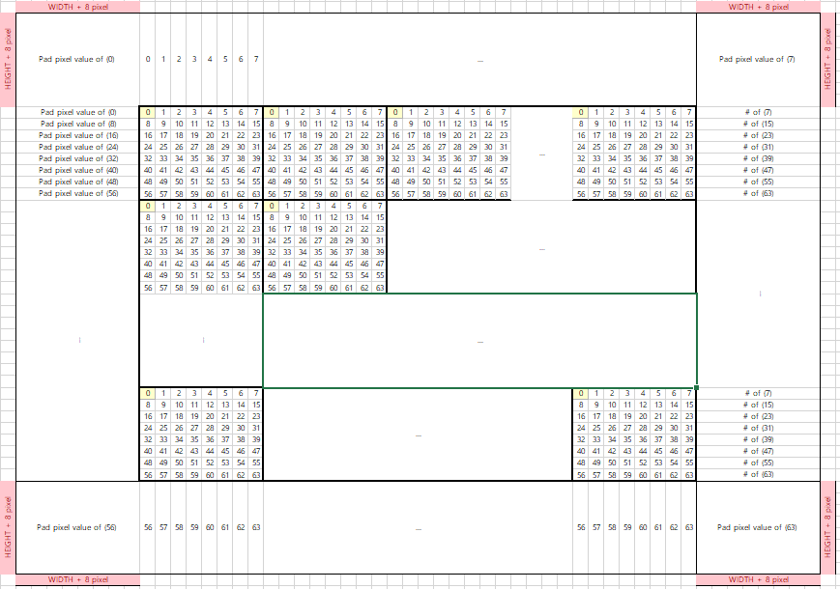
Fig. 1. Padding image (360*296)

- Block coding order

Fig. 2 shows coding order of 4:2:0 format. As you can see, large character numbers mean macro-block order (raster scan order) and small character numbers mean real coding order after transform. In case of 4:2:0 format, sizes of Cb and Cr are half of luma.

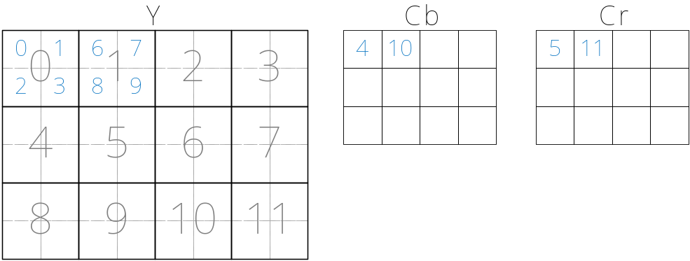
Fig. 2. Coding order for 4:2:0 format.

- Parameter

In this section, we define some parameters such as size, quantization parameter, and some modes.

Size
- 352x288 (CIF),
DPCM modes for DC prediction and pixel prediction
- Mode 0 : Median prediction mode
- Mode 6 : no prediction
Intra prediction flag
- Mode 0/1 : Disable / Enable
Intra period for frame type
- Range : 0 ~ 10, 0 means all predicted frame except first frame.
Quantization Parameter
- For DC, 1 ~ 16
- For AC, 1 ~ 16

Encoder description

Fig. 3 shows the ICSP encoder structure. T and Q mean transform and quantization each. We use simplified intra 8x8 prediction, Discrete Cosine Transform (DCT) as T and uniform quantization with simple dead zone as Q. Zig-zag scan is used for reordering and entropy coder which is like JPEG’s is used. For inter frame, Motion Estimation (ME) and Motion Compensation (MC) are used. Reconstructed frame has to be made using inverse transform and inverse quantization.

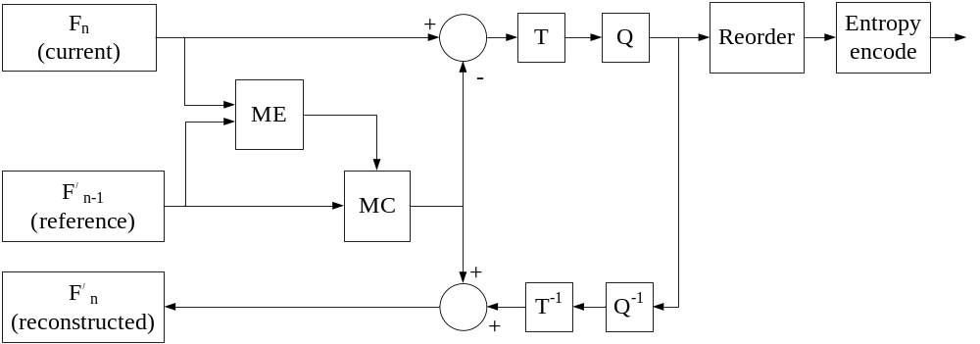
Fig. 3. Block diagram of ICSP encoder.

T : transform ➔ DCT
Q : quantization ➔ general uniform quantization with simple dead zone
Reorder ➔ zig-zag scan
Entropy encoder ➔ like JPEG
- Encoding a intra frame

For encoding the intra frame, green units in Fig. 4 are used.

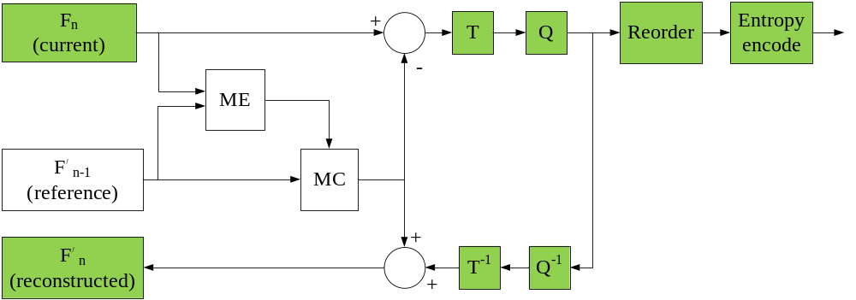
Fig. 4. Block diagram of intra frame.

In case of I frame, first of all, current frame is divided by macro-block. In raster macro-block scan order, after simplified intra 8x8 prediction, pixel based DPCM, discrete cosine transform, and quantization, we also use DPCM for reconstructed (i.e, quantized and inverse quantized) DC component. And then use the reordering (just zig-zag scan) and entropy encoder (like Huffman coding). While doing this forward process, we save the reconstructed data using inverse quantization, inverse transform, inverse DPCM and simplified intra 8x8 prediction for reference of next frame.
- Encoding a inter frame

For encoding the inter frame, green units in Fig. 5 are used.

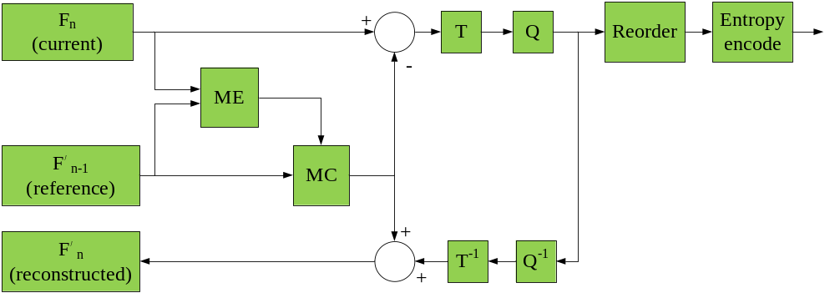
Fig. 5. Block diagram of inter frame.

In case of P frame, using previous reconstructed frame for reference, we use motion estimation to search the best motion vector of current macro-block. After motion estimation, we use DCT, quantization, DPCM for DC, reordering, and entropy coding for error image. We use motion compensation for reconstructed frame. In the inter prediction, we do not use pixel based DPCM.
- Intra 8x8 prediction

We use simplified intra 8x8 prediction. Details of intra prediction is described as H.264/AVC 비디오 압축 표준 [5] and H.264/MPEG-4 Part 10 White Paper: Intra Prediction [10]. There are 8 intra prediction mode for ICSP codec as show in Fig.6. Each 8x8 prediction mode generates 64 predicted pixel values using some or all of the upper and left-hand neighboring pixels as show in Fig.6.
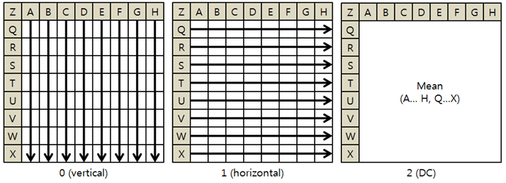
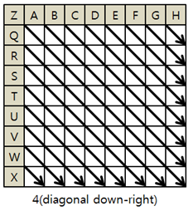

Fig. 6. Four different modes for intra 8x8 prediction

The prediction block created by each of the predictions. The Sum of Absolute Errors (SAE) for each prediction indicates the magnitude of the prediction error. The best matching mode gives the smallest SAE between original block and prediction block. In ICSP codec, only luminance block is predicted. The best matching mode is coded as 2 bit.
- Most probable mode

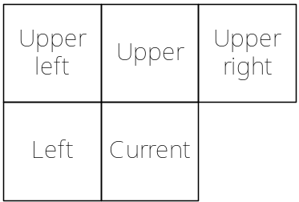
Fig. 7. Positions of the 8x8 block or pixel.

To reduce the mode bit for intra mode, we use prediction using neighboring blocks. If median of Upper, Left, and Upper Left is equal to current mode, MPM_flag will be set to one. If not, MPM_flag will be set to zero and additional fixed mode bit is coded.

- Transform

We use 8x8 block size DCT as transform. The following equations (1) and (2) specify the ideal forward DCT and backward DCT each. But these equations contain cosine terms. In our ICSP codec, we use “double” type instead of “float” type for cosine accuracy.

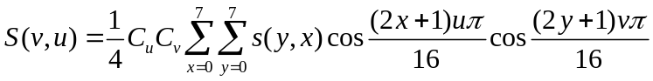 (1)

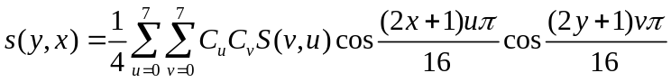 (2)

where
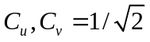 for 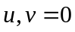
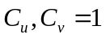 otherwise.

For one 8x8 block, we need 4 overlapping loops. It can be very heavy. We can implement equations (1) and (2) as separable two 3 overlapping loops each. You can reference Jain book [7], “Fundamental of digital image processing”, page 132 to 180. In this book, you have to understand property of transform, energy compaction, and so on. And for each block, you think you may calculate the cosine terms but it is useless. Do not implement equation (1) and (2) themselves. Just use table method after making a cosine table once before transform process.

- Quantization

We just use general quantization. There is only one thing. Be careful with round off. Forward quantization is defined as (3).
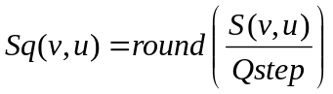 (3)

In (3), 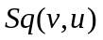is the quantized DCT coefficient, and is the quantization step or quantization parameter. 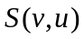is the DCT coefficient. Inverse quantization is defined as (4).

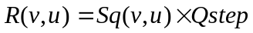 (4)

In (4), 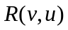 is the inverse quantized DCT coefficients. We use DC for DC coefficient and AC for AC coefficients as .

Be sure that if 0.5 is rounded off, it becomes 1. But if -0.5 is rounded off, it becomes 0 not -1.
- Reordering

We use zig-zag scan to increase a 0 probability sequently. Zig-zag order of quantized DCT coefficients is defined as Fig. 8.

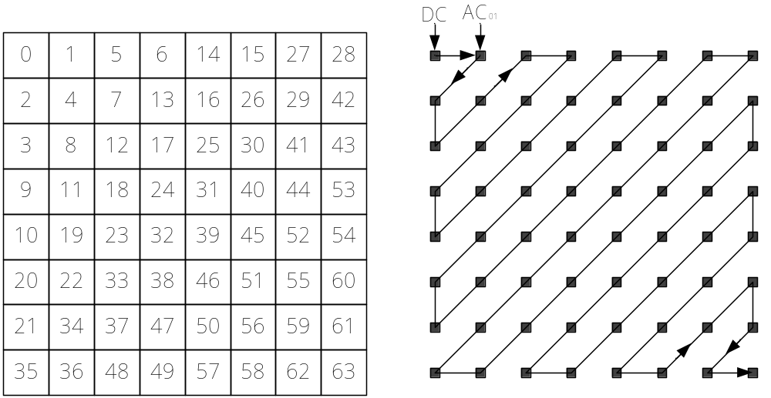
Fig. 8. Zig-zag order of quantized DCT coefficients.

- Differential pulse code modulation (DPCM)

Since the current value is often large compared to 0, we predict the current value using neighboring value. We use DPCM for DC prediction and intra pixel prediction. In the two dimensional signal, we can use neighboring pixel values or DC values of neighboring 8x8 blocks. That’s why we define the DPCM mode. Fig. 9 shows the neighboring 8x8 block positions or pixel positions which we could use.

Fig. 9. Positions of the 8x8 block or pixel.

If upper right position is not available, it can be replaced by upper left position. If current DPCM mode is 0, i.e. median prediction mode, predicted value is median value of left, upper, and upper right positions’ values (it can be DC values or pixel values). In prediction, if left and upper left positions are not available, then their values are replaced by upper position’s value. If upper line is not available, then upper and upper right positions’ values are replaced by left position’s value. Finally, if all neighboring positions are not available, then we assume that predicted value is 1024 in case of DC value because 1024 is the DC value when all pixels in 8x8 block are 128, and in case of pixel, predicted value is 128. In the same way, we can get the predicted value in cases of other modes.

Mode 1 has same way compared with mode 0. Mode 2, 3, and 4 just use the value of each position. Mode 5 means that predicted value is average value of left and upper position’s values.

After DPCM, error value, , is defined as (5).

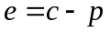 (5)

In (5), and  mean values of current position and predicted value by DPCM mode each.

In case of intra prediction, we use pixel and DC based DPCMs. In case of inter prediction, we use DC based DPCM only because we use ME/MC.
- Motion estimation and compensation

To reduce the temporal redundancy, the block matching algorithm (BMA) for ME has been widely adopted in many video compression standards, because it is simple to implement and effective at decreasing temporal redundancy. In BMA, the current frame is first divided into macro-blocks, which are fixed-sized square blocks, and the motion vector for each macro-block is estimated by finding the most similar block of pixels within its search range in a reference frame according to some matching criteria. The sum of absolute difference (SAD) is often used as a matching criterion between the current macro-block and the candidate blocks because of its lower complexity compared with other matching criteria such as the sum of squared difference (SSD) or the mean square error (MSE). The SAD between a current macro-block and a block of a candidate position within the search range of the reference frame at a relative coordinate  is defined as (6).

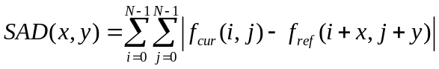 (6)

where N is 16, 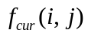 and 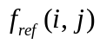 denote the pixel intensity of the current macro-block and the block of the candidate position, respectively.

In ICSP codec, we will implement the FSA [8] with PDE [9] for 8x8 modes each. The best-matched block can be obtained by the FSA, which entails a check of all candidate positions in the search range. FSA uses spiral scan, which is defined as Fig. 10 and Fig. 11. By using this method, we can search the best motion vector of current macro-block more quickly, because the best matching block is close to dc component. PDE uses the partial sum of the matching error to eliminate the impossible candidates before finishing the calculation of the matching error.

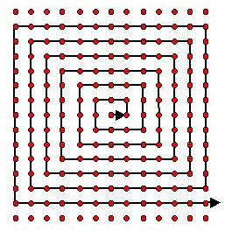

Fig. 10. Spiral scan
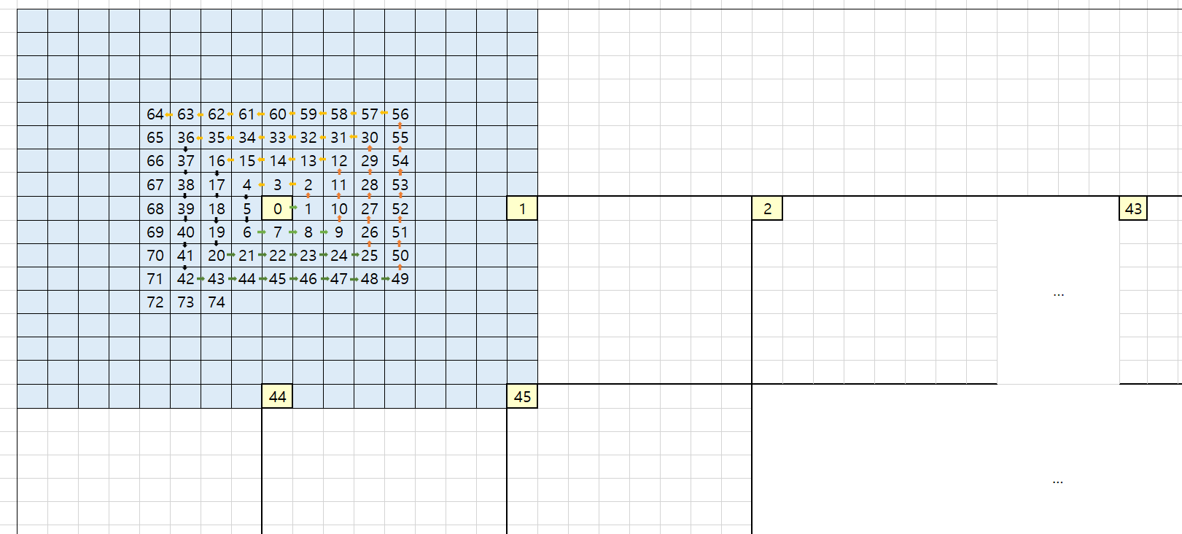
Fig. 11. Spiral scan in every macro block

4.10 Entropy coding

With table I, we implement the entropy coding for motion vector, quantized DC after DPCM, and quantized ACs. It is very simple and looks like JPEG’s table. Sign bit is 1 in case of negative value and 0 in case of positive value.

Table. I. Entropy code for ICSP codec.
Category | Code word | Range | Bit form  Code word + Sign + Range | Total data  length
0 | 00 | 0 | 00 | 2
1 | 010 | 1 | 010 x | 4
2 | 011 | 2,3 | 011 x 0 | 5
3 | 100 | 4,…,7 | 100 x 00 | 6
4 | 101 | 8,…,15 | 101 x 000 | 7
5 | 110 | 16,…,31 | 110 x 0000 | 8
6 | 1110 | 32,…,63 | 1110 x 00000 | 10
7 | 11110 | 64,…,127 | 11110 x 000000 | 12
8 | 111110 | 128,…,255 | 111110 x 0000000 | 14
9 | 1111110 | 256,…,511 | 1111110 x 00000000 | 16
10 | 11111110 | 512,…,1023 | 11111110 x 000000000 | 18
11 | 111111110 | 1024,…,2047 | 111111110 x 0000000000 | 20

Assume that the value to be encoded is -3. The value -3 belongs to the category 2. So code word of -3 is ‘011’. Sign bit is ‘0’ because the sign of -3 is negative. Finally, range of 3 becomes ‘1’ because it is after 2. Consequently, -3 can be represented by ‘01111’. Another example is 18. The value 18 belongs to the category 5. And code word of 18 is ‘110’. Sign bit is ‘0’. Range of 18 is ‘0010’. So 18 can be represented by ‘11000010’.

If ACs in current 8x8 block are all zero for intra and inter predictions, then AC flag is ‘1’, and we skip encoding ACs in current 8x8 block. If ACs in current 8x8 block are not all zero, then AC flag is ‘0’, and encoding all ACs.

Decoder description

Generally, encoder contains decoder. Therefore decoder is very simple.

- Decoder form

Fig. 12 shows the structure of ICSP decoder.
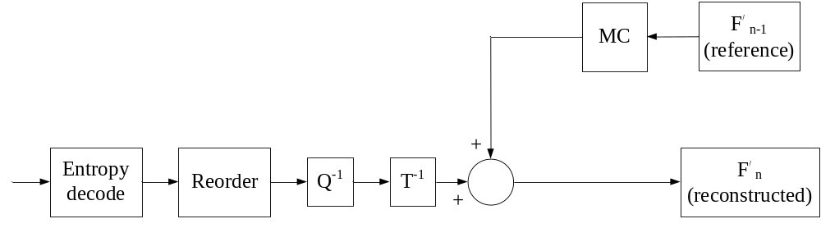
Fig. 12. Block diagram of ICSP decoder.

As you know, Fig. 3 contains Fig. 12.

- Syntax

Stream header is defined as Fig. 13.
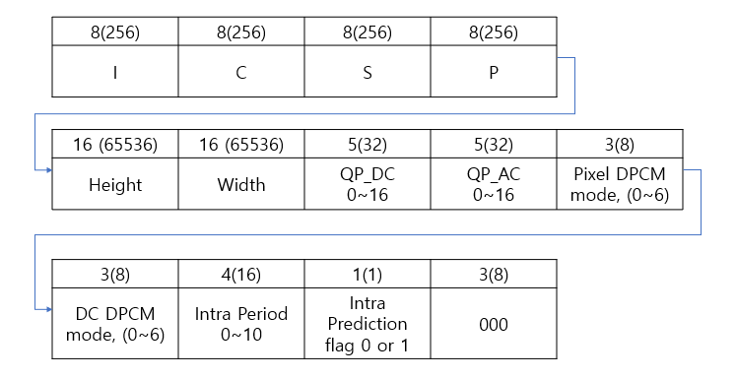
Fig. 13. Stream header for ICSP codec.

It is all 11 bytes. Last 3 bits are all 0. ICSP characters mean ASCII code values.

Macro-block header is defined as Fig. 14. In Fig. 14., (a) and (b) mean intra and inter macro-block header each.

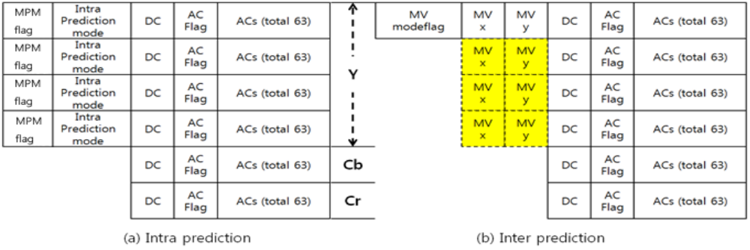
Fig. 14. Macro-block header for intra and inter prediction.

Result and Discussion

6.1 Mandatory configurations for PSNR and size

Test sequence : akiyo (300f), football (90f), and foreman (300f) (only CIF format).
DC QP : 1, 8, and 16.
AC QP : 1 and 16.
DC DPCM mode : 0 and 6.
Pixel DPCM mode : 0, and 6.
MV prediction mode : 0 only.
Intra period : 0 and 10.
Intra prediction enable : 0 and 1

☞ All combinations of above configurations are 432 times. (3x3x2x2x2x1x2x2=288).

Since calculation of PSNR for video sequences is based on PSNR of individual frame distortions, the overall PSNR of the sequence can be calculated in two ways. In one method, the PSNR of individual frames are first calculated and the final PSNR is the average of all PSNRs, as shown in (1) for N frames. In the second method, the average of frame distortions are calculated first and then the PSNR of the average distortion becomes the final PSNR, as shown in (2). The Mean Squared Error (MSE) of each frame is shown in (3). We name the first method as Av-Log and the second method Log-Av. In this Experiment, PSNR of Log-Av is used. Calculation of MSE for Y, Cb, Cr is defined as Fig.15.

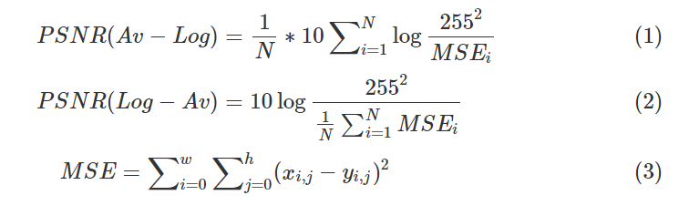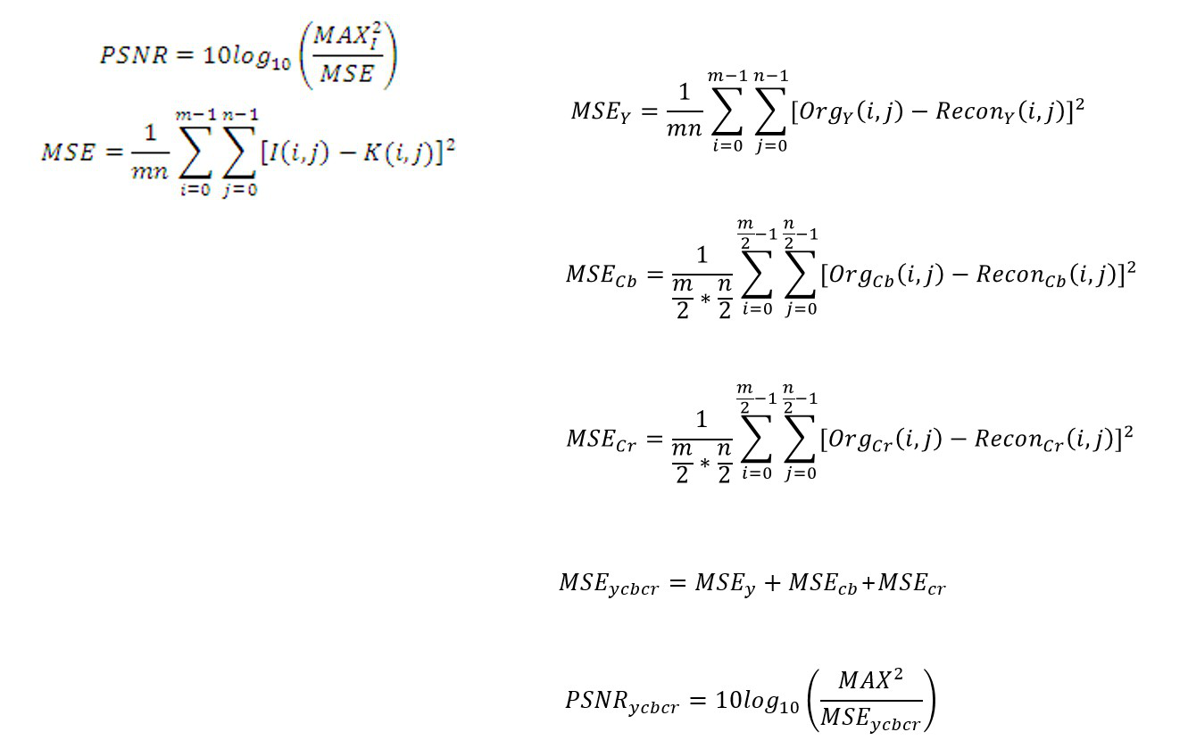

Fig. 15. PSNR formula of one frame

6.2 Experimental result & discussion
Sequence: Akiyo (300f)
Pixel  DPCM | DC  DPCM | Intra  flag | Intra  period | QP  DC | QP  AC | PSNR | FILE SIZE (%)
CASE 1
0 | 0 | 1 | 0 | 1 | 1 | 48.591498 | 51.552182
0 | 0 | 1 | 0 | 8 | 1 | 38.633896 | 52.367665
0 | 0 | 1 | 0 | 16 | 1 | 33.155792 | 54.139119
0 | 0 | 1 | 0 | 1 | 16 | 30.727453 | 17.68697
0 | 0 | 1 | 0 | 8 | 16 | 29.774588 | 17.71596
0 | 0 | 1 | 0 | 16 | 16 | 27.772540 | 20.874169
QP_AC를 1에서 16으로 증가시키는 경우, 압축률이 증가하고 PSNR은 감소함
- Quantization으로 인해 entropy 부호화 시 0을 부호화해야하는 경우가 많아지기 때문에 부호화 표에 따라 비교적 적은 비트로 압축할 수 있어 높은 압축 효율을 얻을 수 있다.
- 양자화 과정에서 데이터 손실이 필연적으로 발생한다. QP값이 커질수록 데이터 손실은 비례하여 나타나므로 PSNR은 감소하는 결과를 볼 수 있었다.
QP_DC를 1에서 16으로 점차 증가시키는 경우, 압축률과 PSNR이 동시에 감소함
- 양자화 계수가 커질수록 복원된 블록과 현재 코딩하는 블록 간의 correlation이 감소하게 되고, 복원된 화소값들을 예측 값으로 사용하는 픽셀 단위 DPCM 부호화 에 의해 예측 값과의 차이가 0에서 더 멀어지는 결과가 나타나게 된다. 이는 엔트로피 부호화 시 비트 수의 증가를 불러온다. 픽셀 단위 DPCM부호화를 사용하는 모든 경우 위와 같이 압축률이 오히려 감소하는 결과가 나타남을 볼 수 있다.
CASE 2
0 | 0 | 1 | 10 | 1 | 1 | 53.949090 | 30.25541
0 | 0 | 1 | 10 | 8 | 1 | 46.999940 | 34.521818
0 | 0 | 1 | 10 | 16 | 1 | 42.459078 | 35.499406
0 | 0 | 1 | 10 | 1 | 16 | 36.033347 | 10.244884
0 | 0 | 1 | 10 | 8 | 16 | 35.641610 | 9.868547
0 | 0 | 1 | 10 | 16 | 16 | 34.295070 | 10.610324
Intra period만 10으로 증가시키면 압축률이 감소하고, psnr도 증가함
- intra예측은 화면 내 주변 화소들과의 유사성을 이용하고, inter예측은 화면 간 유사성을 이용하여 압축 효율을 높인다. akiyo영상은 입 모양만 움직이기 때문에 화면 간 유사성이 매우 크다. 따라서 참조하는 프레임이 inter예측으로 복원된 프레임인 경우부터 inter prediction error값이 intra예측의 경우에 비해 0에 가까운 값을 더 많이 가지게 된다.
- intra예측 프레임은 복원된 주변화소 값을 사용하여 복원되기 때문에 양자화 에러로 인해 발생하는 손실이 주변 블록으로 점점 전파된다. 그러나 inter예측 프레임은 현재프레임 (원본영상) 과 참조프레임 (복원영상) 사이의 움직임 추정, 보상의 과정으로 복원되기 때문에 양자화 과정에서 발생하는 에러 이외에 에러전파가 일어나지 않는다. 따라서 화면 간 유사성이 큰 경우 inter예측 프레임을 증가시킬수록 압축률 증가 효과를 볼 수 있다.
- 또한 chroma성분의 motion vector는 luma성분의 motion vector를 따라가기 때문에 비트스트림을 보내주지 않아도 되므로 비트를 절약할 수 있다.
- inter예측 시 양자화 에러가 주변블록으로 전파되지 않기 때문에 intra예측만 사용했을 때 보다 PSNR이 증가하는 결과가 나타났다.
CASE 3
0 | 0 | 0 | 0 | 1 | 1 | 48.645678 | 48.873584
0 | 0 | 0 | 0 | 8 | 1 | 39.060184 | 49.180862
0 | 0 | 0 | 0 | 16 | 1 | 33.031207 | 50.862426
0 | 0 | 0 | 0 | 1 | 16 | 31.268511 | 13.611352
0 | 0 | 0 | 0 | 8 | 16 | 30.506874 | 12.966744
0 | 0 | 0 | 0 | 16 | 16 | 28.811820 | 15.889091
Intra, Inter 예측 모두 사용하지 않은 경우 압축률, PSNR모두 증가
- DPCM for pixel prediction and DC prediction (median)으로 부호화할 경우 주변 픽셀 또는 DC값 3개를 선택해 중간 값을 예측 값으로 사용하기 때문에 현재 값과 유사하지 않은 경우가 발생하게 된다. intra prediction error값들은 SAD가 최소가 되는 예측모드에 의해 결정되기 때문에 dpcm의 예측 값이 현재 값과 유사하지 않은 값을 선택했을 경우 이 값들이 0에서 더 멀어진다. 여기서 발생한 에러가 양자화 에러와 중첩이 되고 주변 블록으로 전파되어 PSNR이 감소하게 된다. 반면 intra를 사용하지 않은 경우는 원본 값을 그대로 사용하기 때문에 그 수가 크지만 dpcm의 결과로 나온 값들은 intra예측을 사용했을 때보다 0에 더 가까운 값을 갖게 되고 에러전파가 발생하지만 양자화 에러만 전파되므로 압축률과 PSNR이 증가하는 현상이 발생하는 것을 볼 수 있다.
CASE 4
0 | 0 | 0 | 10 | 1 | 1 | 53.940452 | 30.097058
0 | 0 | 0 | 10 | 8 | 1 | 47.256277 | 34.131835
0 | 0 | 0 | 10 | 16 | 1 | 42.561367 | 35.056395
0 | 0 | 0 | 10 | 1 | 16 | 36.687707 | 9.584223
0 | 0 | 0 | 10 | 8 | 16 | 36.390120 | 9.100881
0 | 0 | 0 | 10 | 16 | 16 | 35.246810 | 9.829747
Inter예측을 사용하고, Intra예측은 사용하지 않는 경우 압축률과 PSNR 모두 증가
- intra예측을 사용하지 않기 때문에 화면 내 주변블록으로의 에러전파가 적고, prediction error값들이 0에 더 가까운 값을 가지므로 PSNR과 압축률이 증가한다.
- 화면 간 유사성이 높은 akiyo영상의 경우 inter예측 프레임을 증가시킬수록 더 큰 압축효율을 얻을 수 있고 에러전파 또한 방지할 수 있기 때문에 PSNR이 증가한다.
- case 1, 2, 3, 4중 가장 좋은 성능을 보여준다..
CASE 5
6 | 0 | 1 | 0 | 1 | 1 | 53.959424 | 48.150814
6 | 0 | 1 | 0 | 8 | 1 | 48.059351 | 47.364544
6 | 0 | 1 | 0 | 16 | 1 | 44.895410 | 47.266096
6 | 0 | 1 | 0 | 1 | 16 | 38.265572 | 15.659608
6 | 0 | 1 | 0 | 8 | 16 | 38.115927 | 14.623797
6 | 0 | 1 | 0 | 16 | 16 | 37.578482 | 14.362773
CASE 1과 비교)
intra를 사용하는 경우에 픽셀단위 DPCM만을 적용하지 않는 경우 PSNR과 압축률이 증가함
- 픽셀단위 DPCM을 사용하지 않기 때문에 intra예측 시 발생하는 에러 전파가 줄어든다. 따라서 PSNR이 증가하고, 픽셀간 correlation이 증가하여, 압축률도 증가한다.
- DPCM을 사용하는 목적이 압축률 증가에 있으나, intra와 함께 사용할 경우 압축률이 저하되는 현상을 볼 수 있었다.
CASE 6
6 | 0 | 1 | 10 | 1 | 1 | 54.344452 | 29.997674
6 | 0 | 1 | 10 | 8 | 1 | 48.399581 | 33.07001
6 | 0 | 1 | 10 | 16 | 1 | 45.023800 | 33.522203
6 | 0 | 1 | 10 | 1 | 16 | 38.256655 | 8.412765
6 | 0 | 1 | 10 | 8 | 16 | 38.110402 | 7.714465
6 | 0 | 1 | 10 | 16 | 16 | 37.575004 | 7.65865
CASE 5과 비교)
Inter예측 프레임을 증가시킬수록 압축률은 증가함
- Akiyo는 화면 간 유사성이 높기 때문에 inter예측 시 압축률이 증가함
QP_AC를 16으로 두고 Inter예측 프레임을 증가시키면 PSNR이 감소함
- intra예측만 사용하는 경우 intra prediction error를 양자화 하는 과정에서 QP값에 크기에 비례하여 양자화 손실이 발생하고 이전에 양자화 에러로 인해 손실된 복원 화소값들을 참조하여 다음 블록을 예측한다.
- inter예측 주기의 첫번째 프레임은 양자화로 인해 손실된 intra예측 프레임을 참조하여 현재 프레임을 예측하는데, 이 때 inter예측 시 발생하는 양자화 에러와 중첩이 된다.
- 따라서 inter예측을 사용하지 않는 경우보다 psnr이 더 낮아지는 것을 볼 수 있다.
- Akiyo, foreman, football영상 비교)
화면 간 유사성이 클수록, 즉 움직임이 적은 영상일수록 PSNR이 감소하는 현상이 더 뚜렷하게 나타난다. 이 경우 inter prediction error값들이 더 크게 나오기 때문에 손실되는 정도도 더 커지므로
psnr이 더 큰 폭으로 감소한다.
CASE 7
6 | 0 | 0 | 0 | 1 | 1 | 53.986261 | 47.698276
6 | 0 | 0 | 0 | 8 | 1 | 46.897737 | 46.677412
6 | 0 | 0 | 0 | 16 | 1 | 42.449022 | 46.446327
6 | 0 | 0 | 0 | 1 | 16 | 38.414971 | 17.546498
6 | 0 | 0 | 0 | 8 | 16 | 38.155273 | 16.525634
6 | 0 | 0 | 0 | 16 | 16 | 37.237031 | 16.294549
Case 3과 비교)
intra를 사용하지 않는 경우에 픽셀단위 DPCM만을 적용하지 않는 경우
PSNR 증가
- 픽셀단위 DPCM을 사용하지 않기 때문에 intra예측 시 발생하는 에러 전파가 줄어든다. 따라서 PSNR이 증가한다.
QP_AC가 1인 경우 압축률이 증가함
intra예측을 하지 않기 때문에 MPM_FLAG와 예측모드를 전송하지 않아도 되므로 비트 수를 절약하게 된다. 이 경우 psnr이 증가함에도 압축률 증가효과를 얻을 수 있음.
QP_AC가 16인 경우 압축률이 감소함
dc dpcm 부호화만 사용하는 경우, prediction error의 픽셀 간 correlation이 커진다. 따라서 양자화로 인한 손실이 줄어들고 그 만큼 압축률이 작아진다. 이와 반대로, dc dpcm 부호화와 pixel 단위 dpcm부호화를 같이 사용하는 경우엔, prediction error의 픽셀 간 correlation이 낮아져서 양자화로 인한 손실이 커진다. 손실이 큰 만큼 압축률도 커지기 때문에 다음과 같은 결과를 얻을 수 있었다.

Case 5과 비교)
QP를 AC, DC모두 1로 하고, Intra를 사용하지 않을 경우를 비교하면 psnr이 증가하나, QP값을 증가시키면 psnr이 감소함.
- Intra를 사용하지 않는 경우 원본 화소를 예측 값으로 사용하였기 때문에 psnr은 증가하고 압축률 모두 감소하는 경향을 보여야한다. 다만, QP값이 커질수록 psnr이 감소하는 영향이 더 크기 때문에 psnr이 감소하는 결과가 나타났다.
CASE 8
6 | 0 | 0 | 10 | 1 | 1 | 54.373510 | 29.715909
6 | 0 | 0 | 10 | 8 | 1 | 47.139140 | 32.984068
6 | 0 | 0 | 10 | 16 | 1 | 42.611727 | 33.50089
6 | 0 | 0 | 10 | 1 | 16 | 38.393553 | 8.51297
6 | 0 | 0 | 10 | 8 | 16 | 38.126509 | 7.822752
6 | 0 | 0 | 10 | 16 | 16 | 37.215947 | 7.806994
Case 6과 비교)
QP를 AC, DC모두 1로 하고, Intra를 사용하지 않을 경우를 비교하면 psnr이 증가하나, QP값을 증가시키면 psnr이 감소함.
- Intra를 사용하지 않는 경우 원본 화소를 예측 값으로 사용하였기 때문에 psnr은 증가하고 압축률 모두 감소하는 경향을 보여주어야한다. 다만, QP_DC값이 커질수록 psnr이 감소하는 영향이 더 크기 때문에 psnr이 감소하는 결과가 나타났다.

Case 7과 비교)
Inter예측 프레임을 증가시킬수록 압축률은 증가함
- Akiyo는 화면 간 유사성이 높기 때문에 inter예측 시 압축률이 증가함
QP_AC를 16으로 두고 Inter예측 프레임을 증가시키면 PSNR이 감소함
- 원본 화소값들을 양자화 하는 과정에서 QP값에 크기에 비례하여 양자화 손실이 발생하고 이전에 양자화 에러로 인해 손실된 복원 화소값들을 참조하여 다음 블록을 예측한다.
- inter예측 주기의 첫번째 프레임은 양자화로 인해 손실된 intra예측 프레임을 참조하여 현재 프레임을 예측하는데, 이 때 inter예측 시 발생하는 양자화 에러와 중첩이 된다.
- 따라서 inter예측을 사용하지 않는 경우보다 psnr이 더 낮아지는 것을 볼 수 있다.
Akiyo, foreman, football영상 비교)
화면 간 유사성이 클수록, 즉 움직임이 적은 영상일수록 PSNR이 감소하는 현상이 더 뚜렷하게 나타난다.
- 이 경우 inter prediction error값들이 더 크게 나오기 때문에 손실되는 정도도 더 커지므로
psnr이 더 큰 폭으로 감소한다.
CASE 9
0 | 6 | 1 | 0 | 1 | 1 | 48.591498 | 51.401246
0 | 6 | 1 | 0 | 8 | 1 | 38.633896 | 52.307048
0 | 6 | 1 | 0 | 16 | 1 | 33.155792 | 54.090471
0 | 6 | 1 | 0 | 1 | 16 | 30.727453 | 17.553423
0 | 6 | 1 | 0 | 8 | 16 | 29.774588 | 17.62778
0 | 6 | 1 | 0 | 16 | 16 | 27.772540 | 20.814887
CASE 1과 비교)
Dc dpcm부호화를 적용하지 않을 경우 psnr은 일정, 압축률은 증가
- dc dpcm부호화 시 양자화 에러로 인해 손실되지 않고 무손실로 복원되기 때문에 PSNR에는 영향을 주지 않는다.
- dc dpcm 부호화를 하지 않는 경우 dc 성분이 큰 값으로 유지되기 때문에 부호화 시 많은 비트를 할당받는다. 따라서 압축률이 증가하는 것을 볼 수 있다.
CASE 10
0 | 6 | 1 | 10 | 1 | 1 | 53.949090 | 30.193031
0 | 6 | 1 | 10 | 8 | 1 | 46.999940 | 34.498053
0 | 6 | 1 | 10 | 16 | 1 | 42.459078 | 35.485745
0 | 6 | 1 | 10 | 1 | 16 | 36.033347 | 10.158427
0 | 6 | 1 | 10 | 8 | 16 | 35.641610 | 9.845699
0 | 6 | 1 | 10 | 16 | 16 | 34.295070 | 10.598128
CASE 9와 비교)
Inter예측 프레임을 증가시킬수록
압축률이 증가함
- Akiyo는 화면 간 유사성이 높기 때문에 inter예측 시 압축률이 증가함
- 또한 chroma성분의 motion vector는 luma성분의 motion vector를 따라가기 때문에 비트스트림을 보내주지 않아도 되므로 비트를 절약할 수 있다.
psnr이 증가함
- intra예측 프레임은 복원된 주변화소 값을 사용하여 복원되기 때문에 dpcm과 양자화로 인해 발생하는 에러가 주변 블록으로 점점 전파된다. 반면, inter예측 시 참조프레임으로 intra 예측을 통해 얻어진 복원 프레임을 사용하는 경우 inter prediction error 양자화 시 발생하는 에러가 중첩되긴 하지만 이는 intra예측 시 발생하는 에러 값보다 작다.
- 따라서 pixel단위 dpcm 부호화를 사용하지 않는 경우에 psnr이 더 증가하는 결과를 볼 수 있다.

Akiyo, foreman, football영상 비교)
화면 간 유사성이 클수록, 즉 움직임이 적은 영상일수록 PSNR이 더 크게 증가한다.
- 이 경우 inter prediction error값들이 더 작게 나오기 때문에 손실되는 정도가 적으므로 psnr이 좀 더 증가한다.
CASE 11
0 | 6 | 0 | 0 | 1 | 1 | 48.645678 | 48.768953
0 | 6 | 0 | 0 | 8 | 1 | 39.060184 | 49.114261
0 | 6 | 0 | 0 | 16 | 1 | 33.031207 | 50.810161
0 | 6 | 0 | 0 | 1 | 16 | 31.268511 | 13.511723
0 | 6 | 0 | 0 | 8 | 16 | 30.506874 | 12.900075
0 | 6 | 0 | 0 | 16 | 16 | 28.811820 | 15.837525
Case 3과 비교)
Dc dpcm부호화를 적용하지 않을 경우 psnr은 일정, 압축률은 증가
- dc dpcm부호화 시 양자화 에러로 인해 손실되지 않고 무손실로 복원되기 때문에 PSNR에는 영향을 주지 않는다.
dc dpcm 부호화를 하지 않는 경우 dc 성분이 큰 값으로 유지되기 때문에 부호화 시 많은 비트를 할당받는다. 따라서 압축률이 증가하는 것을 볼 수 있다.

Case 9와 비교)
Intra, Inter 예측 모두 사용하지 않은 경우 압축률, PSNR모두 증가
- DPCM for pixel prediction (median)으로 부호화 할 경우 주변 픽셀 3개 중 중간 값을 예측 값으로 사용하기 때문에 현재 값과 유사하지 않은 경우가 발생하게 된다. intra prediction error값들은 SAD가 최소가 되는 예측모드에 의해 결정되기 때문에 dpcm의 예측 값이 현재 값과 유사하지 않은 값을 선택했을 경우 이 값들이 0에서 더 멀어진다. 여기서 발생한 에러가 양자화 에러와 중첩이 되고 주변 블록으로 전파되어 PSNR이 감소하게 된다. 반면 intra를 사용하지 않은 경우는 원본 값을 그대로 사용하기 때문에 그 수가 크지만 dpcm의 결과로 나온 값들은 intra예측을 사용했을 때보다 0에 더 가까운 값을 갖게 되고 에러전파가 발생하지만 양자화 에러만 전파되므로 압축률과 PSNR이 증가하는 현상이 발생하는 것을 볼 수 있다.
CASE 12
0 | 6 | 0 | 10 | 1 | 1 | 53.940452 | 30.039492
0 | 6 | 0 | 10 | 8 | 1 | 47.256277 | 34.109347
0 | 6 | 0 | 10 | 16 | 1 | 42.561367 | 35.047346
0 | 6 | 0 | 10 | 1 | 16 | 36.687707 | 9.507111
0 | 6 | 0 | 10 | 8 | 16 | 36.390120 | 9.086674
0 | 6 | 0 | 10 | 16 | 16 | 35.246810 | 9.822009
Inter예측을 사용하고, Intra예측은 사용하지 않는 경우 압축률, psnr 증가
- intra예측을 사용하지 않기 때문에 화면 내 주변블록으로의 에러전파가 적고, prediction error값들이 0에 더 가까운 값을 가지므로 PSNR과 압축률이 증가한다.
- 화면 간 유사성이 높은 akiyo영상의 경우 inter예측 프레임을 증가시킬수록 더 큰 압축효율을 얻을 수 있고 에러전파 또한 방지할 수 있기 때문에 PSNR이 증가한다.
- case 9, 10, 11, 12중 가장 좋은 성능을 보여준다.
CASE 13
6 | 6 | 1 | 0 | 1 | 1 | 53.959424 | 48.075284
6 | 6 | 1 | 0 | 8 | 1 | 48.059351 | 47.307232
6 | 6 | 1 | 0 | 16 | 1 | 44.895410 | 47.221012
6 | 6 | 1 | 0 | 1 | 16 | 38.265572 | 15.572511
6 | 6 | 1 | 0 | 8 | 16 | 38.115927 | 14.568785
6 | 6 | 1 | 0 | 16 | 16 | 37.578482 | 14.317022
CASE 9와 비교)
DPCM부호화를 사용하지 않고 intra예측만으로 복원 프레임을 생성한 경우 압축률, psnr 모두 증가
- DPCM for pixel prediction (median)으로 부호화 할 경우 주변 픽셀 3개 중 중간 값을 예측 값으로 사용하기 때문에 현재 값과 유사하지 않은 경우가 발생하게 된다. intra prediction error값들은 SAD가 최소가 되는 예측모드에 의해 결정되기 때문에 dpcm의 예측 값이 현재 값과 유사하지 않은 값을 선택했을 경우 이 값들이 0에서 더 멀어진다. 여기서 발생한 에러가 양자화 에러와 중첩이 되고 주변 블록으로 전파되어 PSNR이 감소하게 된다.
- 따라서 pixel dpcm을 사용하지 않으면 에러 중첩이 발생하지 않기 때문에 psnr은 증가하고
- 비교적 0에 더 가까운 값을 비트스트림으로 만들기 때문에 압축률이 증가한다.
CASE 14
6 | 6 | 1 | 10 | 1 | 1 | 54.344452 | 29.948335
6 | 6 | 1 | 10 | 8 | 1 | 48.399581 | 33.050911
6 | 6 | 1 | 10 | 16 | 1 | 45.023800 | 33.509334
6 | 6 | 1 | 10 | 1 | 16 | 38.256655 | 8.323081
6 | 6 | 1 | 10 | 8 | 16 | 38.110402 | 7.696411
6 | 6 | 1 | 10 | 16 | 16 | 37.575004 | 7.646866
CASE 13과 비교)
Inter예측 프레임을 증가시킬수록 압축률은 증가함
- Akiyo는 화면 간 유사성이 높기 때문에 inter예측 시 압축률이 증가함
QP_AC를 16으로 두고 Inter예측 프레임을 증가시키면 PSNR이 감소함
- intra예측 시 intra prediction error를 양자화 하는 과정에서 QP값에 크기에 비례하여 양자화 손실이 발생하고 이전에 양자화 에러로 인해 손실된 복원 화소 값들을 참조하여 다음 블록을 예측한다.
- inter예측 주기의 첫번째 프레임은 양자화로 인해 손실된 intra예측 프레임을 참조하여 현재 프레임을 예측하는데, 이 때 inter예측 시 발생하는 양자화 에러와 중첩이 된다.
- 따라서 inter예측을 사용하지 않는 경우보다 psnr이 더 낮아지는 것을 볼 수 있다.
- [Akiyo, foreman, football영상 비교]
화면 간 유사성이 클수록, 즉 움직임이 적은 영상일수록 PSNR이 감소하는 현상이 더 뚜렷하게 나타난다. 이 경우 inter prediction error값들이 더 크게 나오기 때문에 손실되는 정도도 더 커지므로
psnr이 더 큰 폭으로 감소한다.
CASE 15
6 | 6 | 0 | 0 | 1 | 1 | 53.986261 | 51.836547
6 | 6 | 0 | 0 | 8 | 1 | 46.897737 | 49.521094
6 | 6 | 0 | 0 | 16 | 1 | 42.449022 | 48.792283
6 | 6 | 0 | 0 | 1 | 16 | 38.414971 | 21.684769
6 | 6 | 0 | 0 | 8 | 16 | 38.155273 | 19.369316
6 | 6 | 0 | 0 | 16 | 16 | 37.237031 | 18.640504
Case 13과 비교)
intra예측과 DPCM 부호화를 사용하지 않는 경우
PSNR 변화
- intra예측모드를 사용하지 않고 원본 화소값을 이용하기 때문에 psnr이 증가한다.
- QP_DC값이 커질수록 psnr의 감소폭은 더 커지므로 psnr이 더 작은 경우가 발생한다.
압축률 변화
intra예측을 하지 않기 때문에 MPM_FLAG와 예측모드를 전송하지 않아도 되므로 비트 수를 절약 할 수 있으나, intra예측을 사용하지 않아 원본값 그대로 전송하기 때문에 prediction error의 픽셀 간 correlation이 작아진다. 따라서 압축률이 감소하는 결과를 볼 수 있다.

Case 11과 비교)
psnr증가
- Intra를 사용하지 않는 경우 원본 화소를 예측 값으로 사용하였기 때문에 psnr은 증가한다..
압축률 감소
- 원본값을 그대로 DCT-Quantization하기 때문에 pixel단위 dpcm prediction error값들 보다 절대값이 상대적으로 더 큰 값들을 비트스트림으로 전송하게 된다. 따라서 압축률이 감소한다.
CASE 16
6 | 6 | 0 | 10 | 1 | 1 | 54.373510 | 30.060332
6 | 6 | 0 | 10 | 8 | 1 | 47.139140 | 33.231852
6 | 6 | 0 | 10 | 16 | 1 | 42.611727 | 33.709557
6 | 6 | 0 | 10 | 1 | 16 | 38.393553 | 8.823405
6 | 6 | 0 | 10 | 8 | 16 | 38.126509 | 8.074887
6 | 6 | 0 | 10 | 16 | 16 | 37.215947 | 8.018337
Case 14와 비교)
QP를 AC, DC모두 1로 하고, Intra를 사용하지 않을 경우를 비교하면 psnr이 증가하나, QP값을 증가시키면 psnr이 감소함.
- Intra를 사용하지 않는 경우 원본 화소를 예측 값으로 사용하였기 때문에 psnr은 증가하고 압축률 모두 감소하는 경향을 보여주어야한다. 다만, QP_DC값이 커질수록 psnr이 감소하는 영향이 더 크기 때문에 psnr이 감소하는 결과가 나타났다.

Case 15과 비교)
Inter예측 프레임을 증가시킬수록 압축률은 증가함
- Akiyo는 화면 간 유사성이 높기 때문에 inter prediction error값이 작아진다. 따라서 부호화 시 할당해야하는 비트 수가 작아지므로 압축률이 증가함
QP_AC를 16으로 두고 Inter예측 프레임을 증가시키면 PSNR이 감소함
- 원본 화소값들을 양자화 하는 과정에서 QP값에 크기에 비례하여 양자화 손실이 발생하고 이전에 양자화 에러로 인해 손실된 복원 화소값들을 참조하여 다음 블록을 예측한다.
- inter예측 주기의 첫번째 프레임은 양자화로 인해 손실된 intra예측 프레임을 참조하여 현재 프레임을 예측하는데, 이 때 inter예측 시 발생하는 양자화 에러와 중첩이 된다.
- 따라서 inter예측을 사용하지 않는 경우보다 psnr이 더 낮아지는 것을 볼 수 있다.
Akiyo, foreman, football영상 비교)
화면 간 유사성이 클수록, 즉 움직임이 적은 영상일수록 PSNR이 감소하는 현상이 더 뚜렷하게 나타난다.
- 이 경우 inter prediction error값들이 더 크게 나오기 때문에 손실되는 정도도 더 커지므로
psnr이 더 큰 폭으로 감소한다.
Sequence: Foreman (300f)
Pixel  DPCM | DC  DPCM | Intra  flag | Intra  period | QP  DC | QP  AC | PSNR | FILE SIZE (%)
CASE 1
0 | 0 | 1 | 0 | 1 | 1 | 48.499081 | 60.507832
0 | 0 | 1 | 0 | 8 | 1 | 38.335796 | 60.800518
0 | 0 | 1 | 0 | 16 | 1 | 33.002599 | 61.776918
0 | 0 | 1 | 0 | 1 | 16 | 29.704377 | 24.789746
0 | 0 | 1 | 0 | 8 | 16 | 28.900693 | 24.535893
0 | 0 | 1 | 0 | 16 | 16 | 27.346131 | 26.401758
CASE 2
0 | 0 | 1 | 10 | 1 | 1 | 53.425778 | 54.038819
0 | 0 | 1 | 10 | 8 | 1 | 46.634797 | 53.819806
0 | 0 | 1 | 10 | 16 | 1 | 42.580352 | 54.032955
0 | 0 | 1 | 10 | 1 | 16 | 33.836352 | 21.624025
0 | 0 | 1 | 10 | 8 | 16 | 33.494470 | 21.070657
0 | 0 | 1 | 10 | 16 | 16 | 32.705780 | 21.618395
CASE 3
0 | 0 | 0 | 0 | 1 | 1 | 48.562852 | 58.281675
0 | 0 | 0 | 0 | 8 | 1 | 38.415377 | 58.218303
0 | 0 | 0 | 0 | 16 | 1 | 32.921976 | 59.096876
0 | 0 | 0 | 0 | 1 | 16 | 30.335855 | 21.431038
0 | 0 | 0 | 0 | 8 | 16 | 29.490384 | 20.838309
0 | 0 | 0 | 0 | 16 | 16 | 27.820687 | 22.427881
CASE 4
0 | 0 | 0 | 10 | 1 | 1 | 53.429444 | 53.849787
0 | 0 | 0 | 10 | 8 | 1 | 46.658702 | 53.574328
0 | 0 | 0 | 10 | 16 | 1 | 42.578278 | 53.788328
0 | 0 | 0 | 10 | 1 | 16 | 34.206465 | 20.901813
0 | 0 | 0 | 10 | 8 | 16 | 33.912414 | 20.286279
0 | 0 | 0 | 10 | 16 | 16 | 33.201896 | 20.737939
CASE 5
0 | 6 | 1 | 0 | 1 | 1 | 48.499081 | 60.359846
0 | 6 | 1 | 0 | 8 | 1 | 38.335796 | 60.722538
0 | 6 | 1 | 0 | 16 | 1 | 33.002599 | 61.720425
0 | 6 | 1 | 0 | 1 | 16 | 29.704377 | 24.640835
0 | 6 | 1 | 0 | 8 | 16 | 28.900693 | 24.439034
0 | 6 | 1 | 0 | 16 | 16 | 27.346131 | 26.331841
CASE 6
0 | 6 | 1 | 10 | 1 | 1 | 53.425778 | 53.973654
0 | 6 | 1 | 10 | 8 | 1 | 46.634797 | 53.777111
0 | 6 | 1 | 10 | 16 | 1 | 42.580352 | 54.007295
0 | 6 | 1 | 10 | 1 | 16 | 33.836352 | 21.551513
0 | 6 | 1 | 10 | 8 | 16 | 33.494470 | 21.022999
0 | 6 | 1 | 10 | 16 | 16 | 32.705780 | 21.589302
CASE 7
0 | 6 | 0 | 0 | 1 | 1 | 48.562852 | 58.170148
0 | 6 | 0 | 0 | 8 | 1 | 38.415377 | 58.15381
0 | 6 | 0 | 0 | 16 | 1 | 32.921976 | 59.048217
0 | 6 | 0 | 0 | 1 | 16 | 30.335855 | 21.324716
0 | 6 | 0 | 0 | 8 | 16 | 29.490384 | 20.766622
0 | 6 | 0 | 0 | 16 | 16 | 27.820687 | 22.37299
CASE 8
0 | 6 | 0 | 10 | 1 | 1 | 53.429444 | 53.787361
0 | 6 | 0 | 10 | 8 | 1 | 46.658702 | 53.534507
0 | 6 | 0 | 10 | 16 | 1 | 42.578278 | 53.766969
0 | 6 | 0 | 10 | 1 | 16 | 34.206465 | 20.835639
0 | 6 | 0 | 10 | 8 | 16 | 33.912414 | 20.244833
0 | 6 | 0 | 10 | 16 | 16 | 33.201896 | 20.715304
CASE 9
6 | 0 | 1 | 0 | 1 | 1 | 53.945245 | 57.552092
6 | 0 | 1 | 0 | 8 | 1 | 47.862251 | 56.632186
6 | 0 | 1 | 0 | 16 | 1 | 44.751394 | 56.460442
6 | 0 | 1 | 0 | 1 | 16 | 35.801052 | 22.956218
6 | 0 | 1 | 0 | 8 | 16 | 35.706675 | 21.910275
6 | 0 | 1 | 0 | 16 | 16 | 35.364145 | 21.707369
CASE 10
6 | 0 | 1 | 10 | 1 | 1 | 53.933961 | 53.724559
6 | 0 | 1 | 10 | 8 | 1 | 47.656948 | 53.266269
6 | 0 | 1 | 10 | 16 | 1 | 44.372508 | 53.195619
6 | 0 | 1 | 10 | 1 | 16 | 35.127182 | 20.144292
6 | 0 | 1 | 10 | 8 | 16 | 35.029439 | 19.291309
6 | 0 | 1 | 10 | 16 | 16 | 34.653576 | 19.273361
CASE 11
6 | 0 | 0 | 0 | 1 | 1 | 53.943143 | 57.241679
6 | 0 | 0 | 0 | 8 | 1 | 47.140572 | 56.122273
6 | 0 | 0 | 0 | 16 | 1 | 42.796147 | 55.871501
6 | 0 | 0 | 0 | 1 | 16 | 35.891309 | 23.129119
6 | 0 | 0 | 0 | 8 | 16 | 35.761767 | 22.009713
6 | 0 | 0 | 0 | 16 | 16 | 35.246386 | 21.758941
CASE 12
6 | 0 | 0 | 10 | 1 | 1 | 53.931912 | 53.695953
6 | 0 | 0 | 10 | 8 | 1 | 47.387717 | 53.227446
6 | 0 | 0 | 10 | 16 | 1 | 43.326805 | 53.16129
6 | 0 | 0 | 10 | 1 | 16 | 35.202827 | 20.075865
6 | 0 | 0 | 10 | 8 | 16 | 35.078482 | 19.22676
6 | 0 | 0 | 10 | 16 | 16 | 34.576585 | 19.220486
CASE 13
6 | 6 | 1 | 0 | 1 | 1 | 53.945245 | 57.440963
6 | 6 | 1 | 0 | 8 | 1 | 47.862251 | 56.564265
6 | 6 | 1 | 0 | 16 | 1 | 44.751394 | 56.409488
6 | 6 | 1 | 0 | 1 | 16 | 35.801052 | 22.840578
6 | 6 | 1 | 0 | 8 | 16 | 35.706675 | 21.83839
6 | 6 | 1 | 0 | 16 | 16 | 35.364145 | 21.651761
CASE 14
6 | 6 | 1 | 10 | 1 | 1 | 53.933961 | 53.662454
6 | 6 | 1 | 10 | 8 | 1 | 47.656948 | 53.226617
6 | 6 | 1 | 10 | 16 | 1 | 44.372508 | 53.170569
6 | 6 | 1 | 10 | 1 | 16 | 35.127182 | 20.075168
6 | 6 | 1 | 10 | 8 | 16 | 35.029439 | 19.246455
6 | 6 | 1 | 10 | 16 | 16 | 34.653576 | 19.244879
CASE 15
6 | 6 | 0 | 0 | 1 | 1 | 53.943143 | 61.378954
6 | 6 | 0 | 0 | 8 | 1 | 47.140572 | 59.051781
6 | 6 | 0 | 0 | 16 | 1 | 42.796147 | 58.282232
6 | 6 | 0 | 0 | 1 | 16 | 35.891309 | 27.266394
6 | 6 | 0 | 0 | 8 | 16 | 35.761767 | 24.939223
6 | 6 | 0 | 0 | 16 | 16 | 35.246386 | 24.169672
CASE 16
6 | 6 | 0 | 10 | 1 | 1 | 53.931912 | 54.030678
6 | 6 | 0 | 10 | 8 | 1 | 47.387717 | 53.465778
6 | 6 | 0 | 10 | 16 | 1 | 43.326805 | 53.364198
6 | 6 | 0 | 10 | 1 | 16 | 35.202827 | 20.40488
6 | 6 | 0 | 10 | 8 | 16 | 35.078482 | 19.46087
6 | 6 | 0 | 10 | 16 | 16 | 34.576585 | 19.421546

Sequence: Football (90f)
Pixel  DPCM | DC  DPCM | Intra  flag | Intra  period | QP  DC | QP  AC | PSNR | FILE SIZE (%)
CASE 1
0 | 0 | 1 | 0 | 1 | 1 | 48.572153 | 55.843636
0 | 0 | 1 | 0 | 8 | 1 | 38.241742 | 56.150897
0 | 0 | 1 | 0 | 16 | 1 | 33.042401 | 57.147188
0 | 0 | 1 | 0 | 1 | 16 | 30.615013 | 24.390797
0 | 0 | 1 | 0 | 8 | 16 | 29.691713 | 24.136095
0 | 0 | 1 | 0 | 16 | 16 | 27.957124 | 25.43554
CASE 2
0 | 0 | 1 | 10 | 1 | 1 | 53.409682 | 55.196767
0 | 0 | 1 | 10 | 8 | 1 | 46.392498 | 54.859489
0 | 0 | 1 | 10 | 16 | 1 | 42.341155 | 54.964883
0 | 0 | 1 | 10 | 1 | 16 | 33.784624 | 25.494185
0 | 0 | 1 | 10 | 8 | 16 | 33.449773 | 24.738093
0 | 0 | 1 | 10 | 16 | 16 | 32.717448 | 25.088691
CASE 3
0 | 0 | 0 | 0 | 1 | 1 | 48.617118 | 53.713086
0 | 0 | 0 | 0 | 8 | 1 | 38.238374 | 53.51336
0 | 0 | 0 | 0 | 16 | 1 | 32.881162 | 54.32063
0 | 0 | 0 | 0 | 1 | 16 | 31.339167 | 21.721819
0 | 0 | 0 | 0 | 8 | 16 | 30.396012 | 21.115773
0 | 0 | 0 | 0 | 16 | 16 | 28.421897 | 22.411141
CASE 4
0 | 0 | 0 | 10 | 1 | 1 | 53.421862 | 54.975098
0 | 0 | 0 | 10 | 8 | 1 | 46.392630 | 54.581207
0 | 0 | 0 | 10 | 16 | 1 | 42.307438 | 54.676277
0 | 0 | 0 | 10 | 1 | 16 | 34.169651 | 24.942122
0 | 0 | 0 | 10 | 8 | 16 | 33.912692 | 24.082769
0 | 0 | 0 | 10 | 16 | 16 | 33.069728 | 24.443582
CASE 5
6 | 0 | 1 | 0 | 1 | 1 | 53.980116 | 52.66515
6 | 0 | 1 | 0 | 8 | 1 | 47.590191 | 51.746962
6 | 0 | 1 | 0 | 16 | 1 | 44.431891 | 51.559322
6 | 0 | 1 | 0 | 1 | 16 | 36.766270 | 23.469343
6 | 0 | 1 | 0 | 8 | 16 | 36.626290 | 22.431257
6 | 0 | 1 | 0 | 16 | 16 | 36.187105 | 22.204752
CASE 6
6 | 0 | 1 | 10 | 1 | 1 | 53.950644 | 54.850743
6 | 0 | 1 | 10 | 8 | 1 | 47.350485 | 54.296371
6 | 0 | 1 | 10 | 16 | 1 | 43.645961 | 54.17979
6 | 0 | 1 | 10 | 1 | 16 | 34.997021 | 24.762724
6 | 0 | 1 | 10 | 8 | 16 | 34.856657 | 23.769254
6 | 0 | 1 | 10 | 16 | 16 | 34.454237 | 23.66527
CASE 7
6 | 0 | 0 | 0 | 1 | 1 | 53.980001 | 52.388052
6 | 0 | 0 | 0 | 8 | 1 | 47.087349 | 51.268625
6 | 0 | 0 | 0 | 16 | 1 | 42.819359 | 50.999754
6 | 0 | 0 | 0 | 1 | 16 | 36.887160 | 23.785979
6 | 0 | 0 | 0 | 8 | 16 | 36.693110 | 22.66656
6 | 0 | 0 | 0 | 16 | 16 | 36.055048 | 22.397682
CASE 8
6 | 0 | 0 | 10 | 1 | 1 | 53.948862 | 54.812623
6 | 0 | 0 | 10 | 8 | 1 | 47.282516 | 54.243747
6 | 0 | 0 | 10 | 16 | 1 | 43.322536 | 54.128386
6 | 0 | 0 | 10 | 1 | 16 | 35.054703 | 24.757295
6 | 0 | 0 | 10 | 8 | 16 | 34.899495 | 23.748648
6 | 0 | 0 | 10 | 16 | 16 | 34.357303 | 23.751688
CASE 9
0 | 6 | 1 | 0 | 1 | 1 | 48.572153 | 55.690265
0 | 6 | 1 | 0 | 8 | 1 | 38.241742 | 56.066108
0 | 6 | 1 | 0 | 16 | 1 | 33.042401 | 57.085423
0 | 6 | 1 | 0 | 1 | 16 | 30.615013 | 24.23728
0 | 6 | 1 | 0 | 8 | 16 | 29.691713 | 24.035896
0 | 6 | 1 | 0 | 16 | 16 | 27.957124 | 25.362727
CASE 10
0 | 6 | 1 | 10 | 1 | 1 | 53.409682 | 55.159721
0 | 6 | 1 | 10 | 8 | 1 | 46.392498 | 54.824935
0 | 6 | 1 | 10 | 16 | 1 | 42.341155 | 54.94172
0 | 6 | 1 | 10 | 1 | 16 | 33.784624 | 25.454348
0 | 6 | 1 | 10 | 8 | 16 | 33.449773 | 24.699344
0 | 6 | 1 | 10 | 16 | 16 | 32.717448 | 25.063336
CASE 11
0 | 6 | 0 | 0 | 1 | 1 | 48.617118 | 53.586114
0 | 6 | 0 | 0 | 8 | 1 | 38.238374 | 53.437661
0 | 6 | 0 | 0 | 16 | 1 | 32.881162 | 54.266705
0 | 6 | 0 | 0 | 1 | 16 | 31.339167 | 21.591815
0 | 6 | 0 | 0 | 8 | 16 | 30.396012 | 21.036771
0 | 6 | 0 | 0 | 16 | 16 | 28.421897 | 22.354308
CASE 12
0 | 6 | 0 | 10 | 1 | 1 | 53.421862 | 54.940968
0 | 6 | 0 | 10 | 8 | 1 | 46.392630 | 54.549079
0 | 6 | 0 | 10 | 16 | 1 | 42.307438 | 54.657323
0 | 6 | 0 | 10 | 1 | 16 | 34.169651 | 24.905851
0 | 6 | 0 | 10 | 8 | 16 | 33.912692 | 24.04877
0 | 6 | 0 | 10 | 16 | 16 | 33.069728 | 24.425001
CASE 13
6 | 6 | 1 | 0 | 1 | 1 | 53.980116 | 52.543578
6 | 6 | 1 | 0 | 8 | 1 | 47.590191 | 51.671752
6 | 6 | 1 | 0 | 16 | 1 | 44.431891 | 51.502014
6 | 6 | 1 | 0 | 1 | 16 | 36.766270 | 23.341839
6 | 6 | 1 | 0 | 8 | 16 | 36.626290 | 22.354418
6 | 6 | 1 | 0 | 16 | 16 | 36.187105 | 22.144287
CASE 14
6 | 6 | 1 | 10 | 1 | 1 | 53.950644 | 54.816225
6 | 6 | 1 | 10 | 8 | 1 | 47.350485 | 54.263936
6 | 6 | 1 | 10 | 16 | 1 | 43.645961 | 54.15708
6 | 6 | 1 | 10 | 1 | 16 | 34.997021 | 24.726541
6 | 6 | 1 | 10 | 8 | 16 | 34.856657 | 23.731769
6 | 6 | 1 | 10 | 16 | 16 | 34.454237 | 23.640258
CASE 15
6 | 6 | 0 | 0 | 1 | 1 | 53.980001 | 56.372302
6 | 6 | 0 | 0 | 8 | 1 | 47.087349 | 54.03499
6 | 6 | 0 | 0 | 16 | 1 | 42.819359 | 53.262194
6 | 6 | 0 | 0 | 1 | 16 | 36.887160 | 27.770237
6 | 6 | 0 | 0 | 8 | 16 | 36.693110 | 25.432917
6 | 6 | 0 | 0 | 16 | 16 | 36.055048 | 24.660128
CASE 16
6 | 6 | 0 | 10 | 1 | 1 | 53.948862 | 55.1903
6 | 6 | 0 | 10 | 8 | 1 | 47.282516 | 54.495278
6 | 6 | 0 | 10 | 16 | 1 | 43.322536 | 54.337523
6 | 6 | 0 | 10 | 1 | 16 | 35.054703 | 25.134198
6 | 6 | 0 | 10 | 8 | 16 | 34.899495 | 23.996957
6 | 6 | 0 | 10 | 16 | 16 | 34.357303 | 23.958326

no predictive coding
sequence | Pixel  dpcm | Dc  dpcm | Intra  enable | Intra  period | QP  DC | QP  AC | PSNR | File size
Akiyo | 6 | 6 | 0 | 0 | 1 | 1 | 53.986261 | 51.836547
Foreman | 6 | 6 | 0 | 0 | 1 | 1 | 53.943143 | 61.378954
football | 6 | 6 | 0 | 0 | 1 | 1 | 53.980001 | 56.372302

sequence | Pixel  dpcm | Dc  dpcm | Intra  enable | Intra  period | QP  DC | QP  AC | PSNR | File size
Akiyo | 6 | 6 | 0 | 0 | 8 | 1 | 46.897737 | 49.521094
Foreman | 6 | 6 | 0 | 0 | 8 | 1 | 47.140572 | 59.051781
football | 6 | 6 | 0 | 0 | 8 | 1 | 47.087349 | 54.03499

sequence | Pixel  dpcm | Dc  dpcm | Intra  enable | Intra  period | QP  DC | QP  AC | PSNR | File size
Akiyo | 6 | 6 | 0 | 0 | 16 | 1 | 42.449022 | 48.792283
Foreman | 6 | 6 | 0 | 0 | 16 | 1 | 42.796147 | 58.282232
football | 6 | 6 | 0 | 0 | 16 | 1 | 42.819359 | 53.262194

sequence | Pixel  dpcm | Dc  dpcm | Intra  enable | Intra  period | QP  DC | QP  AC | PSNR | File size
Akiyo | 6 | 6 | 0 | 0 | 1 | 16 | 38.414971 | 21.684769
Foreman | 6 | 6 | 0 | 0 | 1 | 16 | 35.891309 | 27.266394
football | 6 | 6 | 0 | 0 | 1 | 16 | 36.88716 | 27.770237

sequence | Pixel  dpcm | Dc  dpcm | Intra  enable | Intra  period | QP  DC | QP  AC | PSNR | File size
Akiyo | 6 | 6 | 0 | 0 | 8 | 16 | 38.155273 | 19.369316
Foreman | 6 | 6 | 0 | 0 | 8 | 16 | 35.761767 | 24.939223
football | 6 | 6 | 0 | 0 | 8 | 16 | 36.69311 | 25.432917

sequence | Pixel  dpcm | Dc  dpcm | Intra  enable | Intra  period | QP  DC | QP  AC | PSNR | File size
Akiyo | 6 | 6 | 0 | 0 | 16 | 16 | 37.237031 | 18.640504
Foreman | 6 | 6 | 0 | 0 | 16 | 16 | 35.246386 | 24.169672
football | 6 | 6 | 0 | 0 | 16 | 16 | 36.055048 | 24.660128
only intra
sequence | Pixel  dpcm | Dc  dpcm | Intra  enable | Intra  period | QP  DC | QP  AC | PSNR | File size
Akiyo | 6 | 6 | 1 | 0 | 1 | 1 | 53.959424 | 48.075284
Foreman | 6 | 6 | 1 | 0 | 1 | 1 | 53.945245 | 57.440963
football | 6 | 6 | 1 | 0 | 1 | 1 | 53.980116 | 52.543578

sequence | Pixel  dpcm | Dc  dpcm | Intra  enable | Intra  period | QP  DC | QP  AC | PSNR | File size
Akiyo | 6 | 6 | 1 | 0 | 8 | 1 | 48.059351 | 47.307232
Foreman | 6 | 6 | 1 | 0 | 8 | 1 | 47.862251 | 56.564265
football | 6 | 6 | 1 | 0 | 8 | 1 | 47.590191 | 51.671752

sequence | Pixel  dpcm | Dc  dpcm | Intra  enable | Intra  period | QP  DC | QP  AC | PSNR | File size
Akiyo | 6 | 6 | 1 | 0 | 16 | 1 | 44.89541 | 47.221012
Foreman | 6 | 6 | 1 | 0 | 16 | 1 | 44.751394 | 56.409488
football | 6 | 6 | 1 | 0 | 16 | 1 | 44.431891 | 51.502014

sequence | Pixel  dpcm | Dc  dpcm | Intra  enable | Intra  period | QP  DC | QP  AC | PSNR | File size
Akiyo | 6 | 6 | 1 | 0 | 1 | 16 | 38.265572 | 15.572511
Foreman | 6 | 6 | 1 | 0 | 1 | 16 | 35.801052 | 22.840578
football | 6 | 6 | 1 | 0 | 1 | 16 | 36.76627 | 23.341839

sequence | Pixel  dpcm | Dc  dpcm | Intra  enable | Intra  period | QP  DC | QP  AC | PSNR | File size
Akiyo | 6 | 6 | 1 | 0 | 8 | 16 | 38.115927 | 14.568785
Foreman | 6 | 6 | 1 | 0 | 8 | 16 | 35.706675 | 21.83839
football | 6 | 6 | 1 | 0 | 8 | 16 | 36.62629 | 22.354418

sequence | Pixel  dpcm | Dc  dpcm | Intra  enable | Intra  period | QP  DC | QP  AC | PSNR | File size
Akiyo | 6 | 6 | 1 | 0 | 16 | 16 | 37.578482 | 14.317022
Foreman | 6 | 6 | 1 | 0 | 16 | 16 | 35.364145 | 21.651761
football | 6 | 6 | 1 | 0 | 16 | 16 | 36.187105 | 22.144287
only inter prediction
sequence | Pixel  dpcm | Dc  dpcm | Intra  enable | Intra  period | QP  DC | QP  AC | PSNR | File size
Akiyo | 6 | 6 | 0 | 10 | 1 | 1 | 54.37351 | 30.060332
Foreman | 6 | 6 | 0 | 10 | 1 | 1 | 53.931912 | 54.030678
football | 6 | 6 | 0 | 10 | 1 | 1 | 53.948862 | 55.1903

sequence | Pixel  dpcm | Dc  dpcm | Intra  enable | Intra  period | QP  DC | QP  AC | PSNR | File size
Akiyo | 6 | 6 | 0 | 10 | 8 | 1 | 47.13914 | 33.231852
Foreman | 6 | 6 | 0 | 10 | 8 | 1 | 47.387717 | 53.465778
football | 6 | 6 | 0 | 10 | 8 | 1 | 47.282516 | 54.495278

sequence | Pixel  dpcm | Dc  dpcm | Intra  enable | Intra  period | QP  DC | QP  AC | PSNR | File size
Akiyo | 6 | 6 | 0 | 10 | 16 | 1 | 42.611727 | 33.709557
Foreman | 6 | 6 | 0 | 10 | 16 | 1 | 43.326805 | 53.364198
football | 6 | 6 | 0 | 10 | 16 | 1 | 43.322536 | 54.337523

sequence | Pixel  dpcm | Dc  dpcm | Intra  enable | Intra  period | QP  DC | QP  AC | PSNR | File size
Akiyo | 6 | 6 | 0 | 10 | 1 | 16 | 38.393553 | 8.823405
Foreman | 6 | 6 | 0 | 10 | 1 | 16 | 35.202827 | 20.40488
football | 6 | 6 | 0 | 10 | 1 | 16 | 35.054703 | 25.134198

sequence | Pixel  dpcm | Dc  dpcm | Intra  enable | Intra  period | QP  DC | QP  AC | PSNR | File size
Akiyo | 6 | 6 | 0 | 10 | 8 | 16 | 38.126509 | 8.074887
Foreman | 6 | 6 | 0 | 10 | 8 | 16 | 35.078482 | 19.46087
football | 6 | 6 | 0 | 10 | 8 | 16 | 34.899495 | 23.996957

sequence | Pixel  dpcm | Dc  dpcm | Intra  enable | Intra  period | QP  DC | QP  AC | PSNR | File size
Akiyo | 6 | 6 | 0 | 10 | 16 | 16 | 37.215947 | 8.018337
Foreman | 6 | 6 | 0 | 10 | 16 | 16 | 34.576585 | 19.421546
football | 6 | 6 | 0 | 10 | 16 | 16 | 34.357303 | 23.958326
only intra and inter prediction
sequence | Pixel  dpcm | Dc  dpcm | Intra  enable | Intra  period | QP  DC | QP  AC | PSNR | File size
Akiyo | 6 | 6 | 1 | 10 | 1 | 1 | 54.344452 | 29.948335
Foreman | 6 | 6 | 1 | 10 | 1 | 1 | 53.933961 | 53.662454
football | 6 | 6 | 1 | 10 | 1 | 1 | 53.950644 | 54.816225

sequence | Pixel  dpcm | Dc  dpcm | Intra  enable | Intra  period | QP  DC | QP  AC | PSNR | File size
Akiyo | 6 | 6 | 1 | 10 | 8 | 1 | 48.399581 | 33.050911
Foreman | 6 | 6 | 1 | 10 | 8 | 1 | 47.656948 | 53.226617
football | 6 | 6 | 1 | 10 | 8 | 1 | 47.350485 | 54.263936

sequence | Pixel  dpcm | Dc  dpcm | Intra  enable | Intra  period | QP  DC | QP  AC | PSNR | File size
Akiyo | 6 | 6 | 1 | 10 | 16 | 1 | 45.0238 | 33.509334
Foreman | 6 | 6 | 1 | 10 | 16 | 1 | 44.372508 | 53.170569
football | 6 | 6 | 1 | 10 | 16 | 1 | 43.645961 | 54.15708

sequence | Pixel  dpcm | Dc  dpcm | Intra  enable | Intra  period | QP  DC | QP  AC | PSNR | File size
Akiyo | 6 | 6 | 1 | 10 | 1 | 16 | 38.256655 | 8.323081
Foreman | 6 | 6 | 1 | 10 | 1 | 16 | 35.127182 | 20.075168
football | 6 | 6 | 1 | 10 | 1 | 16 | 34.997021 | 24.726541

sequence | Pixel  dpcm | Dc  dpcm | Intra  enable | Intra  period | QP  DC | QP  AC | PSNR | File size
Akiyo | 6 | 6 | 1 | 10 | 8 | 16 | 38.110402 | 7.696411
Foreman | 6 | 6 | 1 | 10 | 8 | 16 | 35.029439 | 19.246455
football | 6 | 6 | 1 | 10 | 8 | 16 | 34.856657 | 23.731769

sequence | Pixel  dpcm | Dc  dpcm | Intra  enable | Intra  period | QP  DC | QP  AC | PSNR | File size
Akiyo | 6 | 6 | 1 | 10 | 16 | 16 | 37.575004 | 7.646866
Foreman | 6 | 6 | 1 | 10 | 16 | 16 | 34.653576 | 19.244879
football | 6 | 6 | 1 | 10 | 16 | 16 | 34.454237 | 23.640258
only pixel DPCM
sequence | Pixel  dpcm | Dc  dpcm | Intra  enable | Intra  period | QP  DC | QP  AC | PSNR | File size
Akiyo | 0 | 6 | 0 | 0 | 1 | 1 | 48.645678 | 48.768953
Foreman | 0 | 6 | 0 | 0 | 1 | 1 | 48.562852 | 58.170148
football | 0 | 6 | 0 | 0 | 1 | 1 | 48.617118 | 53.586114

sequence | Pixel  dpcm | Dc  dpcm | Intra  enable | Intra  period | QP  DC | QP  AC | PSNR | File size
Akiyo | 0 | 6 | 0 | 0 | 8 | 1 | 39.060184 | 49.114261
Foreman | 0 | 6 | 0 | 0 | 8 | 1 | 38.415377 | 58.15381
football | 0 | 6 | 0 | 0 | 8 | 1 | 38.238374 | 53.437661

sequence | Pixel  dpcm | Dc  dpcm | Intra  enable | Intra  period | QP  DC | QP  AC | PSNR | File size
Akiyo | 0 | 6 | 0 | 0 | 16 | 1 | 33.031207 | 50.810161
Foreman | 0 | 6 | 0 | 0 | 16 | 1 | 32.921976 | 59.048217
football | 0 | 6 | 0 | 0 | 16 | 1 | 32.881162 | 54.266705

sequence | Pixel  dpcm | Dc  dpcm | Intra  enable | Intra  period | QP  DC | QP  AC | PSNR | File size
Akiyo | 0 | 6 | 0 | 0 | 1 | 16 | 31.268511 | 13.511723
Foreman | 0 | 6 | 0 | 0 | 1 | 16 | 30.335855 | 21.324716
football | 0 | 6 | 0 | 0 | 1 | 16 | 31.339167 | 21.591815

sequence | Pixel  dpcm | Dc  dpcm | Intra  enable | Intra  period | QP  DC | QP  AC | PSNR | File size
Akiyo | 0 | 6 | 0 | 0 | 8 | 16 | 30.506874 | 12.900075
Foreman | 0 | 6 | 0 | 0 | 8 | 16 | 29.490384 | 20.766622
football | 0 | 6 | 0 | 0 | 8 | 16 | 30.396012 | 21.036771

sequence | Pixel  dpcm | Dc  dpcm | Intra  enable | Intra  period | QP  DC | QP  AC | PSNR | File size
Akiyo | 0 | 6 | 0 | 0 | 16 | 16 | 28.81182 | 15.837525
Foreman | 0 | 6 | 0 | 0 | 16 | 16 | 27.820687 | 22.37299
football | 0 | 6 | 0 | 0 | 16 | 16 | 28.421897 | 22.354308
pixel DPCM and intra prediction
sequence | Pixel  dpcm | Dc  dpcm | Intra  enable | Intra  period | QP  DC | QP  AC | PSNR | File size
Akiyo | 0 | 6 | 1 | 0 | 1 | 1 | 48.591498 | 51.401246
Foreman | 0 | 6 | 1 | 0 | 1 | 1 | 48.499081 | 60.359846
football | 0 | 6 | 1 | 0 | 1 | 1 | 48.572153 | 55.690265

sequence | Pixel  dpcm | Dc  dpcm | Intra  enable | Intra  period | QP  DC | QP  AC | PSNR | File size
Akiyo | 0 | 6 | 1 | 0 | 8 | 1 | 38.633896 | 52.307048
Foreman | 0 | 6 | 1 | 0 | 8 | 1 | 38.335796 | 60.722538
football | 0 | 6 | 1 | 0 | 8 | 1 | 38.241742 | 56.066108

sequence | Pixel  dpcm | Dc  dpcm | Intra  enable | Intra  period | QP  DC | QP  AC | PSNR | File size
Akiyo | 0 | 6 | 1 | 0 | 16 | 1 | 33.155792 | 54.090471
Foreman | 0 | 6 | 1 | 0 | 16 | 1 | 33.002599 | 61.720425
football | 0 | 6 | 1 | 0 | 16 | 1 | 33.042401 | 57.085423

sequence | Pixel  dpcm | Dc  dpcm | Intra  enable | Intra  period | QP  DC | QP  AC | PSNR | File size
Akiyo | 0 | 6 | 1 | 0 | 1 | 16 | 30.727453 | 17.553423
Foreman | 0 | 6 | 1 | 0 | 1 | 16 | 29.704377 | 24.640835
football | 0 | 6 | 1 | 0 | 1 | 16 | 30.615013 | 24.23728

sequence | Pixel  dpcm | Dc  dpcm | Intra  enable | Intra  period | QP  DC | QP  AC | PSNR | File size
Akiyo | 0 | 6 | 1 | 0 | 8 | 16 | 29.774588 | 17.62778
Foreman | 0 | 6 | 1 | 0 | 8 | 16 | 28.900693 | 24.439034
football | 0 | 6 | 1 | 0 | 8 | 16 | 29.691713 | 24.035896

sequence | Pixel  dpcm | Dc  dpcm | Intra  enable | Intra  period | QP  DC | QP  AC | PSNR | File size
Akiyo | 0 | 6 | 1 | 0 | 16 | 16 | 27.77254 | 20.814887
Foreman | 0 | 6 | 1 | 0 | 16 | 16 | 27.346131 | 26.331841
football | 0 | 6 | 1 | 0 | 16 | 16 | 27.957124 | 25.362727
pixel DPCM and inter prediction
sequence | Pixel  dpcm | Dc  dpcm | Intra  enable | Intra  period | QP  DC | QP  AC | PSNR | File size
Akiyo | 0 | 6 | 0 | 10 | 1 | 1 | 53.940452 | 30.039492
Foreman | 0 | 6 | 0 | 10 | 1 | 1 | 53.429444 | 53.787361
football | 0 | 6 | 0 | 10 | 1 | 1 | 53.421862 | 54.940968

sequence | Pixel  dpcm | Dc  dpcm | Intra  enable | Intra  period | QP  DC | QP  AC | PSNR | File size
Akiyo | 0 | 6 | 0 | 10 | 8 | 1 | 47.256277 | 34.109347
Foreman | 0 | 6 | 0 | 10 | 8 | 1 | 46.658702 | 53.534507
football | 0 | 6 | 0 | 10 | 8 | 1 | 46.39263 | 54.549079

sequence | Pixel  dpcm | Dc  dpcm | Intra  enable | Intra  period | QP  DC | QP  AC | PSNR | File size
Akiyo | 0 | 6 | 0 | 10 | 16 | 1 | 42.561367 | 35.047346
Foreman | 0 | 6 | 0 | 10 | 16 | 1 | 42.578278 | 53.766969
football | 0 | 6 | 0 | 10 | 16 | 1 | 42.307438 | 54.657323

sequence | Pixel  dpcm | Dc  dpcm | Intra  enable | Intra  period | QP  DC | QP  AC | PSNR | File size
Akiyo | 0 | 6 | 0 | 10 | 1 | 16 | 36.687707 | 9.507111
Foreman | 0 | 6 | 0 | 10 | 1 | 16 | 34.206465 | 20.835639
football | 0 | 6 | 0 | 10 | 1 | 16 | 34.169651 | 24.905851

sequence | Pixel  dpcm | Dc  dpcm | Intra  enable | Intra  period | QP  DC | QP  AC | PSNR | File size
Akiyo | 0 | 6 | 0 | 10 | 8 | 16 | 36.39012 | 9.086674
Foreman | 0 | 6 | 0 | 10 | 8 | 16 | 33.912414 | 20.244833
football | 0 | 6 | 0 | 10 | 8 | 16 | 33.912692 | 24.04877

sequence | Pixel  dpcm | Dc  dpcm | Intra  enable | Intra  period | QP  DC | QP  AC | PSNR | File size
Akiyo | 0 | 6 | 0 | 10 | 16 | 16 | 35.24681 | 9.822009
Foreman | 0 | 6 | 0 | 10 | 16 | 16 | 33.201896 | 20.715304
football | 0 | 6 | 0 | 10 | 16 | 16 | 33.069728 | 24.425001
no dc dpcm
sequence | Pixel  dpcm | Dc  dpcm | Intra  enable | Intra  period | QP  DC | QP  AC | PSNR | File size
Akiyo | 0 | 6 | 1 | 10 | 1 | 1 | 53.94909 | 30.193031
Foreman | 0 | 6 | 1 | 10 | 1 | 1 | 53.425778 | 53.973654
football | 0 | 6 | 1 | 10 | 1 | 1 | 53.409682 | 55.159721

sequence | Pixel  dpcm | Dc  dpcm | Intra  enable | Intra  period | QP  DC | QP  AC | PSNR | File size
Akiyo | 0 | 6 | 1 | 10 | 8 | 1 | 46.99994 | 34.498053
Foreman | 0 | 6 | 1 | 10 | 8 | 1 | 46.634797 | 53.777111
football | 0 | 6 | 1 | 10 | 8 | 1 | 46.392498 | 54.824935

sequence | Pixel  dpcm | Dc  dpcm | Intra  enable | Intra  period | QP  DC | QP  AC | PSNR | File size
Akiyo | 0 | 6 | 1 | 10 | 16 | 1 | 42.459078 | 35.485745
Foreman | 0 | 6 | 1 | 10 | 16 | 1 | 42.580352 | 54.007295
football | 0 | 6 | 1 | 10 | 16 | 1 | 42.341155 | 54.94172

sequence | Pixel  dpcm | Dc  dpcm | Intra  enable | Intra  period | QP  DC | QP  AC | PSNR | File size
Akiyo | 0 | 6 | 1 | 10 | 1 | 16 | 36.033347 | 10.158427
Foreman | 0 | 6 | 1 | 10 | 1 | 16 | 33.836352 | 21.551513
football | 0 | 6 | 1 | 10 | 1 | 16 | 33.784624 | 25.454348

sequence | Pixel  dpcm | Dc  dpcm | Intra  enable | Intra  period | QP  DC | QP  AC | PSNR | File size
Akiyo | 0 | 6 | 1 | 10 | 8 | 16 | 35.64161 | 9.845699
Foreman | 0 | 6 | 1 | 10 | 8 | 16 | 33.49447 | 21.022999
football | 0 | 6 | 1 | 10 | 8 | 16 | 33.449773 | 24.699344

sequence | Pixel  dpcm | Dc  dpcm | Intra  enable | Intra  period | QP  DC | QP  AC | PSNR | File size
Akiyo | 0 | 6 | 1 | 10 | 16 | 16 | 34.29507 | 10.598128
Foreman | 0 | 6 | 1 | 10 | 16 | 16 | 32.70578 | 21.589302
football | 0 | 6 | 1 | 10 | 16 | 16 | 32.717448 | 25.063336
only dc DPCM
sequence | Pixel  dpcm | Dc  dpcm | Intra  enable | Intra  period | QP  DC | QP  AC | PSNR | File size
Akiyo | 6 | 0 | 0 | 0 | 1 | 1 | 53.986261 | 47.698276
Foreman | 6 | 0 | 0 | 0 | 1 | 1 | 53.943143 | 57.241679
football | 6 | 0 | 0 | 0 | 1 | 1 | 53.980001 | 52.388052

sequence | Pixel  dpcm | Dc  dpcm | Intra  enable | Intra  period | QP  DC | QP  AC | PSNR | File size
Akiyo | 6 | 0 | 0 | 0 | 8 | 1 | 46.897737 | 46.677412
Foreman | 6 | 0 | 0 | 0 | 8 | 1 | 47.140572 | 56.122273
football | 6 | 0 | 0 | 0 | 8 | 1 | 47.087349 | 51.268625

sequence | Pixel  dpcm | Dc  dpcm | Intra  enable | Intra  period | QP  DC | QP  AC | PSNR | File size
Akiyo | 6 | 0 | 0 | 0 | 16 | 1 | 42.449022 | 46.446327
Foreman | 6 | 0 | 0 | 0 | 16 | 1 | 42.796147 | 55.871501
football | 6 | 0 | 0 | 0 | 16 | 1 | 42.819359 | 50.999754

sequence | Pixel  dpcm | Dc  dpcm | Intra  enable | Intra  period | QP  DC | QP  AC | PSNR | File size
Akiyo | 6 | 0 | 0 | 0 | 1 | 16 | 38.414971 | 17.546498
Foreman | 6 | 0 | 0 | 0 | 1 | 16 | 35.891309 | 23.129119
football | 6 | 0 | 0 | 0 | 1 | 16 | 36.88716 | 23.785979

sequence | Pixel  dpcm | Dc  dpcm | Intra  enable | Intra  period | QP  DC | QP  AC | PSNR | File size
Akiyo | 6 | 0 | 0 | 0 | 8 | 16 | 38.155273 | 16.525634
Foreman | 6 | 0 | 0 | 0 | 8 | 16 | 35.761767 | 22.009713
football | 6 | 0 | 0 | 0 | 8 | 16 | 36.69311 | 22.66656

sequence | Pixel  dpcm | Dc  dpcm | Intra  enable | Intra  period | QP  DC | QP  AC | PSNR | File size
Akiyo | 6 | 0 | 0 | 0 | 16 | 16 | 37.237031 | 16.294549
Foreman | 6 | 0 | 0 | 0 | 16 | 16 | 35.246386 | 21.758941
football | 6 | 0 | 0 | 0 | 16 | 16 | 36.055048 | 22.397682
dc DPCM and intra prediction
sequence | Pixel  dpcm | Dc  dpcm | Intra  enable | Intra  period | QP  DC | QP  AC | PSNR | File size
Akiyo | 6 | 0 | 1 | 0 | 1 | 1 | 53.959424 | 48.150814
Foreman | 6 | 0 | 1 | 0 | 1 | 1 | 53.945245 | 57.552092
football | 6 | 0 | 1 | 0 | 1 | 1 | 53.980116 | 52.66515

sequence | Pixel  dpcm | Dc  dpcm | Intra  enable | Intra  period | QP  DC | QP  AC | PSNR | File size
Akiyo | 6 | 0 | 1 | 0 | 8 | 1 | 48.059351 | 47.364544
Foreman | 6 | 0 | 1 | 0 | 8 | 1 | 47.862251 | 56.632186
football | 6 | 0 | 1 | 0 | 8 | 1 | 47.590191 | 51.746962

sequence | Pixel  dpcm | Dc  dpcm | Intra  enable | Intra  period | QP  DC | QP  AC | PSNR | File size
Akiyo | 6 | 0 | 1 | 0 | 16 | 1 | 44.89541 | 47.266096
Foreman | 6 | 0 | 1 | 0 | 16 | 1 | 44.751394 | 56.460442
football | 6 | 0 | 1 | 0 | 16 | 1 | 44.431891 | 51.559322

sequence | Pixel  dpcm | Dc  dpcm | Intra  enable | Intra  period | QP  DC | QP  AC | PSNR | File size
Akiyo | 6 | 0 | 1 | 0 | 1 | 16 | 38.265572 | 15.659608
Foreman | 6 | 0 | 1 | 0 | 1 | 16 | 35.801052 | 22.956218
football | 6 | 0 | 1 | 0 | 1 | 16 | 36.76627 | 23.469343

sequence | Pixel  dpcm | Dc  dpcm | Intra  enable | Intra  period | QP  DC | QP  AC | PSNR | File size
Akiyo | 6 | 0 | 1 | 0 | 8 | 16 | 38.115927 | 14.623797
Foreman | 6 | 0 | 1 | 0 | 8 | 16 | 35.706675 | 21.910275
football | 6 | 0 | 1 | 0 | 8 | 16 | 36.62629 | 22.431257

sequence | Pixel  dpcm | Dc  dpcm | Intra  enable | Intra  period | QP  DC | QP  AC | PSNR | File size
Akiyo | 6 | 0 | 1 | 0 | 16 | 16 | 37.578482 | 14.362773
Foreman | 6 | 0 | 1 | 0 | 16 | 16 | 35.364145 | 21.707369
football | 6 | 0 | 1 | 0 | 16 | 16 | 36.187105 | 22.204752
dc DPCM and inter prediction
sequence | Pixel  dpcm | Dc  dpcm | Intra  enable | Intra  period | QP  DC | QP  AC | PSNR | File size
Akiyo | 6 | 0 | 0 | 10 | 1 | 1 | 54.37351 | 29.715909
Foreman | 6 | 0 | 0 | 10 | 1 | 1 | 53.931912 | 53.695953
football | 6 | 0 | 0 | 10 | 1 | 1 | 53.948862 | 54.812623

sequence | Pixel  dpcm | Dc  dpcm | Intra  enable | Intra  period | QP  DC | QP  AC | PSNR | File size
Akiyo | 6 | 0 | 0 | 10 | 8 | 1 | 47.13914 | 32.984068
Foreman | 6 | 0 | 0 | 10 | 8 | 1 | 47.387717 | 53.227446
football | 6 | 0 | 0 | 10 | 8 | 1 | 47.282516 | 54.243747

sequence | Pixel  dpcm | Dc  dpcm | Intra  enable | Intra  period | QP  DC | QP  AC | PSNR | File size
Akiyo | 6 | 0 | 0 | 10 | 16 | 1 | 42.611727 | 33.50089
Foreman | 6 | 0 | 0 | 10 | 16 | 1 | 43.326805 | 53.16129
football | 6 | 0 | 0 | 10 | 16 | 1 | 43.322536 | 54.128386

sequence | Pixel  dpcm | Dc  dpcm | Intra  enable | Intra  period | QP  DC | QP  AC | PSNR | File size
Akiyo | 6 | 0 | 0 | 10 | 1 | 16 | 38.393553 | 8.51297
Foreman | 6 | 0 | 0 | 10 | 1 | 16 | 35.202827 | 20.075865
football | 6 | 0 | 0 | 10 | 1 | 16 | 35.054703 | 24.757295

sequence | Pixel  dpcm | Dc  dpcm | Intra  enable | Intra  period | QP  DC | QP  AC | PSNR | File size
Akiyo | 6 | 0 | 0 | 10 | 8 | 16 | 38.126509 | 7.822752
Foreman | 6 | 0 | 0 | 10 | 8 | 16 | 35.078482 | 19.22676
football | 6 | 0 | 0 | 10 | 8 | 16 | 34.899495 | 23.748648

sequence | Pixel  dpcm | Dc  dpcm | Intra  enable | Intra  period | QP  DC | QP  AC | PSNR | File size
Akiyo | 6 | 0 | 0 | 10 | 16 | 16 | 37.215947 | 7.806994
Foreman | 6 | 0 | 0 | 10 | 16 | 16 | 34.576585 | 19.220486
football | 6 | 0 | 0 | 10 | 16 | 16 | 34.357303 | 23.751688
no pixel DPCM
sequence | Pixel  dpcm | Dc  dpcm | Intra  enable | Intra  period | QP  DC | QP  AC | PSNR | File size
Akiyo | 6 | 0 | 1 | 10 | 1 | 1 | 54.344452 | 29.997674
Foreman | 6 | 0 | 1 | 10 | 1 | 1 | 53.933961 | 53.724559
football | 6 | 0 | 1 | 10 | 1 | 1 | 53.950644 | 54.850743

sequence | Pixel  dpcm | Dc  dpcm | Intra  enable | Intra  period | QP  DC | QP  AC | PSNR | File size
Akiyo | 6 | 0 | 1 | 10 | 8 | 1 | 48.399581 | 33.07001
Foreman | 6 | 0 | 1 | 10 | 8 | 1 | 47.656948 | 53.266269
football | 6 | 0 | 1 | 10 | 8 | 1 | 47.350485 | 54.296371

sequence | Pixel  dpcm | Dc  dpcm | Intra  enable | Intra  period | QP  DC | QP  AC | PSNR | File size
Akiyo | 6 | 0 | 1 | 10 | 16 | 1 | 45.0238 | 33.522203
Foreman | 6 | 0 | 1 | 10 | 16 | 1 | 44.372508 | 53.195619
football | 6 | 0 | 1 | 10 | 16 | 1 | 43.645961 | 54.17979

sequence | Pixel  dpcm | Dc  dpcm | Intra  enable | Intra  period | QP  DC | QP  AC | PSNR | File size
Akiyo | 6 | 0 | 1 | 10 | 1 | 16 | 38.256655 | 8.412765
Foreman | 6 | 0 | 1 | 10 | 1 | 16 | 35.127182 | 20.144292
football | 6 | 0 | 1 | 10 | 1 | 16 | 34.997021 | 24.762724

sequence | Pixel  dpcm | Dc  dpcm | Intra  enable | Intra  period | QP  DC | QP  AC | PSNR | File size
Akiyo | 6 | 0 | 1 | 10 | 8 | 16 | 38.110402 | 7.714465
Foreman | 6 | 0 | 1 | 10 | 8 | 16 | 35.029439 | 19.291309
football | 6 | 0 | 1 | 10 | 8 | 16 | 34.856657 | 23.769254

sequence | Pixel  dpcm | Dc  dpcm | Intra  enable | Intra  period | QP  DC | QP  AC | PSNR | File size
Akiyo | 6 | 0 | 1 | 10 | 16 | 16 | 37.575004 | 7.65865
Foreman | 6 | 0 | 1 | 10 | 16 | 16 | 34.653576 | 19.273361
football | 6 | 0 | 1 | 10 | 16 | 16 | 34.454237 | 23.66527
only DPCM
sequence | Pixel  dpcm | Dc  dpcm | Intra  enable | Intra  period | QP  DC | QP  AC | PSNR | File size
Akiyo | 0 | 0 | 0 | 0 | 1 | 1 | 48.645678 | 48.873584
Foreman | 0 | 0 | 0 | 0 | 1 | 1 | 48.562852 | 58.281675
football | 0 | 0 | 0 | 0 | 1 | 1 | 48.617118 | 53.713086

sequence | Pixel  dpcm | Dc  dpcm | Intra  enable | Intra  period | QP  DC | QP  AC | PSNR | File size
Akiyo | 0 | 0 | 0 | 0 | 8 | 1 | 39.060184 | 49.180862
Foreman | 0 | 0 | 0 | 0 | 8 | 1 | 38.415377 | 58.218303
football | 0 | 0 | 0 | 0 | 8 | 1 | 38.238374 | 53.51336

sequence | Pixel  dpcm | Dc  dpcm | Intra  enable | Intra  period | QP  DC | QP  AC | PSNR | File size
Akiyo | 0 | 0 | 0 | 0 | 16 | 1 | 33.031207 | 50.862426
Foreman | 0 | 0 | 0 | 0 | 16 | 1 | 32.921976 | 59.096876
football | 0 | 0 | 0 | 0 | 16 | 1 | 32.881162 | 54.32063

sequence | Pixel  dpcm | Dc  dpcm | Intra  enable | Intra  period | QP  DC | QP  AC | PSNR | File size
Akiyo | 0 | 0 | 0 | 0 | 1 | 16 | 31.268511 | 13.611352
Foreman | 0 | 0 | 0 | 0 | 1 | 16 | 30.335855 | 21.431038
football | 0 | 0 | 0 | 0 | 1 | 16 | 31.339167 | 21.721819

sequence | Pixel  dpcm | Dc  dpcm | Intra  enable | Intra  period | QP  DC | QP  AC | PSNR | File size
Akiyo | 0 | 0 | 0 | 0 | 8 | 16 | 30.506874 | 12.966744
Foreman | 0 | 0 | 0 | 0 | 8 | 16 | 29.490384 | 20.838309
football | 0 | 0 | 0 | 0 | 8 | 16 | 30.396012 | 21.115773

sequence | Pixel  dpcm | Dc  dpcm | Intra  enable | Intra  period | QP  DC | QP  AC | PSNR | File size
Akiyo | 0 | 0 | 0 | 0 | 16 | 16 | 28.81182 | 15.889091
Foreman | 0 | 0 | 0 | 0 | 16 | 16 | 27.820687 | 22.427881
Football | 0 | 0 | 0 | 0 | 16 | 16 | 28.421897 | 22.411141
no intra prediction
sequence | Pixel  dpcm | Dc  dpcm | Intra  enable | Intra  period | QP  DC | QP  AC | PSNR | File size
Akiyo | 0 | 0 | 0 | 10 | 1 | 1 | 53.940452 | 30.097058
Foreman | 0 | 0 | 0 | 10 | 1 | 1 | 53.429444 | 53.849787
football | 0 | 0 | 0 | 10 | 1 | 1 | 53.421862 | 54.975098

sequence | Pixel  dpcm | Dc  dpcm | Intra  enable | Intra  period | QP  DC | QP  AC | PSNR | File size
Akiyo | 0 | 0 | 0 | 10 | 8 | 1 | 47.256277 | 34.131835
Foreman | 0 | 0 | 0 | 10 | 8 | 1 | 46.658702 | 53.574328
football | 0 | 0 | 0 | 10 | 8 | 1 | 46.39263 | 54.581207

sequence | Pixel  dpcm | Dc  dpcm | Intra  enable | Intra  period | QP  DC | QP  AC | PSNR | File size
Akiyo | 0 | 0 | 0 | 10 | 16 | 1 | 42.561367 | 35.056395
Foreman | 0 | 0 | 0 | 10 | 16 | 1 | 42.578278 | 53.788328
football | 0 | 0 | 0 | 10 | 16 | 1 | 42.307438 | 54.676277

sequence | Pixel  dpcm | Dc  dpcm | Intra  enable | Intra  period | QP  DC | QP  AC | PSNR | File size
Akiyo | 0 | 0 | 0 | 10 | 1 | 16 | 36.687707 | 9.584223
Foreman | 0 | 0 | 0 | 10 | 1 | 16 | 34.206465 | 20.901813
football | 0 | 0 | 0 | 10 | 1 | 16 | 34.169651 | 24.942122

sequence | Pixel  dpcm | Dc  dpcm | Intra  enable | Intra  period | QP  DC | QP  AC | PSNR | File size
Akiyo | 0 | 0 | 0 | 10 | 8 | 16 | 36.39012 | 9.100881
Foreman | 0 | 0 | 0 | 10 | 8 | 16 | 33.912414 | 20.286279
football | 0 | 0 | 0 | 10 | 8 | 16 | 33.912692 | 24.082769

sequence | Pixel  dpcm | Dc  dpcm | Intra  enable | Intra  period | QP  DC | QP  AC | PSNR | File size
Akiyo | 0 | 0 | 0 | 10 | 16 | 16 | 35.24681 | 9.829747
Foreman | 0 | 0 | 0 | 10 | 16 | 16 | 33.201896 | 20.737939
football | 0 | 0 | 0 | 10 | 16 | 16 | 33.069728 | 24.443582
no inter prediction
sequence | Pixel  dpcm | Dc  dpcm | Intra  enable | Intra  period | QP  DC | QP  AC | PSNR | File size
Akiyo | 0 | 0 | 1 | 0 | 1 | 1 | 48.591498 | 51.552182
Foreman | 0 | 0 | 1 | 0 | 1 | 1 | 48.499081 | 60.507832
football | 0 | 0 | 1 | 0 | 1 | 1 | 48.572153 | 55.843636

sequence | Pixel  dpcm | Dc  dpcm | Intra  enable | Intra  period | QP  DC | QP  AC | PSNR | File size
Akiyo | 0 | 0 | 1 | 0 | 8 | 1 | 38.633896 | 52.367665
Foreman | 0 | 0 | 1 | 0 | 8 | 1 | 38.335796 | 60.800518
football | 0 | 0 | 1 | 0 | 8 | 1 | 38.241742 | 56.150897

sequence | Pixel  dpcm | Dc  dpcm | Intra  enable | Intra  period | QP  DC | QP  AC | PSNR | File size
Akiyo | 0 | 0 | 1 | 0 | 16 | 1 | 33.155792 | 54.139119
Foreman | 0 | 0 | 1 | 0 | 16 | 1 | 33.002599 | 61.776918
football | 0 | 0 | 1 | 0 | 16 | 1 | 33.042401 | 57.147188

sequence | Pixel  dpcm | Dc  dpcm | Intra  enable | Intra  period | QP  DC | QP  AC | PSNR | File size
Akiyo | 0 | 0 | 1 | 0 | 1 | 16 | 30.727453 | 17.68697
Foreman | 0 | 0 | 1 | 0 | 1 | 16 | 29.704377 | 24.789746
football | 0 | 0 | 1 | 0 | 1 | 16 | 30.615013 | 24.390797

sequence | Pixel  dpcm | Dc  dpcm | Intra  enable | Intra  period | QP  DC | QP  AC | PSNR | File size
Akiyo | 0 | 0 | 1 | 0 | 8 | 16 | 29.774588 | 17.71596
Foreman | 0 | 0 | 1 | 0 | 8 | 16 | 28.900693 | 24.535893
football | 0 | 0 | 1 | 0 | 8 | 16 | 29.691713 | 24.136095

sequence | Pixel  dpcm | Dc  dpcm | Intra  enable | Intra  period | QP  DC | QP  AC | PSNR | File size
Akiyo | 0 | 0 | 1 | 0 | 16 | 16 | 27.77254 | 20.874169
Foreman | 0 | 0 | 1 | 0 | 16 | 16 | 27.346131 | 26.401758
football | 0 | 0 | 1 | 0 | 16 | 16 | 27.957124 | 25.43554
Apply all predictive coding
sequence | Pixel  dpcm | Dc  dpcm | Intra  enable | Intra  period | QP  DC | QP  AC | PSNR | File size
Akiyo | 0 | 0 | 1 | 10 | 1 | 1 | 53.94909 | 30.25541
Foreman | 0 | 0 | 1 | 10 | 1 | 1 | 53.425778 | 54.038819
football | 0 | 0 | 1 | 10 | 1 | 1 | 53.409682 | 55.196767

sequence | Pixel  dpcm | Dc  dpcm | Intra  enable | Intra  period | QP  DC | QP  AC | PSNR | File size
Akiyo | 0 | 0 | 1 | 10 | 8 | 1 | 46.99994 | 34.521818
Foreman | 0 | 0 | 1 | 10 | 8 | 1 | 46.634797 | 53.819806
football | 0 | 0 | 1 | 10 | 8 | 1 | 46.392498 | 54.859489

sequence | Pixel  dpcm | Dc  dpcm | Intra  enable | Intra  period | QP  DC | QP  AC | PSNR | File size
Akiyo | 0 | 0 | 1 | 10 | 16 | 1 | 42.459078 | 35.499406
Foreman | 0 | 0 | 1 | 10 | 16 | 1 | 42.580352 | 54.032955
football | 0 | 0 | 1 | 10 | 16 | 1 | 42.341155 | 54.964883

sequence | Pixel  dpcm | Dc  dpcm | Intra  enable | Intra  period | QP  DC | QP  AC | PSNR | File size
Akiyo | 0 | 0 | 1 | 10 | 1 | 16 | 36.033347 | 10.244884
Foreman | 0 | 0 | 1 | 10 | 1 | 16 | 33.836352 | 21.624025
football | 0 | 0 | 1 | 10 | 1 | 16 | 33.784624 | 25.494185

sequence | Pixel  dpcm | Dc  dpcm | Intra  enable | Intra  period | QP  DC | QP  AC | PSNR | File size
Akiyo | 0 | 0 | 1 | 10 | 8 | 16 | 35.64161 | 9.868547
Foreman | 0 | 0 | 1 | 10 | 8 | 16 | 33.49447 | 21.070657
football | 0 | 0 | 1 | 10 | 8 | 16 | 33.449773 | 24.738093

sequence | Pixel  dpcm | Dc  dpcm | Intra  enable | Intra  period | QP  DC | QP  AC | PSNR | File size
Akiyo | 0 | 0 | 1 | 10 | 16 | 16 | 34.29507 | 10.610324
Foreman | 0 | 0 | 1 | 10 | 16 | 16 | 32.70578 | 21.618395
football | 0 | 0 | 1 | 10 | 16 | 16 | 32.717448 | 25.088691

Conclusion

총 288가지의 실험결과 중 sequence별로 압축률이 제일 좋게 나온 경우 상위 6개를 아래표로 정리하였다. 실험 결과를 통해 알 수 있는 사실을 크게 프레임 내 유사성, 프레임 간 유사성으로 구분하였고 마지막으로 실험 결과 분석 시 예외적인 케이스가 발생하는 이유를 정리하였다.

첫째, 프레임 내 이웃한 픽셀들은 유사성이 크기 때문에 즉, 픽셀 값의 차이가 적을 확률이 높기 때문에 그 차이 값을 전송하는 것이 픽셀 값 전체를 전송하는 것보다 더 적은 비트를 가지고 전송할 수 있다. 따라서 화면 내 패턴이 복잡하지 않은 영상일수록 DPCM부호화방식과 intra예측부호화 방식을 사용하는 것이 더 효율적이다.

둘째, 움직임이 별로 없는 영상일수록 inter 예측 프레임을 많이 할수록 압축이 잘되며, 움직임이 많고 역동적인 영상일수록 inter예측보다는 intra예측 프레임을 많이 사용하는 것이 더 큰 압축효과를 볼 수 있다. 역동적인 영상일수록 intra 예측 프레임이 많이 사용하는 것이 더 큰 압축효과를 얻을 수 있으며, 이 때 pixel dpcm 방식을 적용한 경우가 대부분 더 큰 압축효과를 볼 수 있다.

마지막으로, 실험 결과 분석이 어려웠던 점은 pixel DPCM을 사용하는 경우였다. 원래 dpcm은 무손실 압축이기 때문에 복원 시 똑 같은 영상을 볼 수 있다. 그러나 본 실험에서는 DCT-Quantization과정에서 발생하는 round off, 양자화 에러로 인해 블록단위 코딩 시 에러가 이미지 전체로 전파되어 손실압축이 발생하여 PSNR이 오히려 좋지 않게 나오는 경우가 발생하였다. median mode은 현재 코딩하는 픽셀 주변 3개 화소의 중간값을 예측값으로 사용하여 차분값을 계산하기 때문에 intra prediction error값들을 구한 뒤, dpcm을 적용하면 오히려 픽셀 값의 차이가 더 커지는 경우가 발생하여 압축률이 감소하는 경우가 발생하기도 했다. 따라서 결과 분석 시 Pixel DPCM을 사용하는 것이 예외적인 경우를 만드는 원인이 되어, 실제 압축률 향상을 의도한 목적과 다른 결과가 나오게 되었다.

akiyo_cif(352X288)_300f
Pixel  dpcm | Dc  dpcm | Intra  enable | Intra  period | QP  DC | QP  AC | PSNR | File size
6 | 6 | 1 | 10 | 16 | 16 | 37.575004 | 7.646866
6 | 0 | 1 | 10 | 16 | 16 | 37.575004 | 7.65865
6 | 6 | 1 | 10 | 8 | 16 | 38.110402 | 7.696411
6 | 0 | 1 | 10 | 8 | 16 | 38.110402 | 7.714465
6 | 0 | 0 | 10 | 16 | 16 | 37.215947 | 7.806994
6 | 0 | 0 | 10 | 8 | 16 | 38.126509 | 7.822752

foreman_cif(352X288)_300f
Pixel  dpcm | Dc  dpcm | Intra  enable | Intra  period | QP  DC | QP  AC | PSNR | File size
6 | 0 | 0 | 10 | 16 | 16 | 34.576585 | 19.220486
6 | 0 | 0 | 10 | 8 | 16 | 35.078482 | 19.22676
6 | 6 | 1 | 10 | 16 | 16 | 34.653576 | 19.244879
6 | 6 | 1 | 10 | 8 | 16 | 35.029439 | 19.246455
6 | 0 | 1 | 10 | 16 | 16 | 34.653576 | 19.273361
6 | 0 | 1 | 10 | 8 | 16 | 35.029439 | 19.291309

football_cif(352X288)_90f
Pixel  dpcm | Dc  dpcm | Intra  enable | Intra  period | QP  DC | QP  AC | PSNR | File size
0 | 6 | 0 | 0 | 8 | 16 | 30.396012 | 21.036771
0 | 0 | 0 | 0 | 8 | 16 | 30.396012 | 21.115773
0 | 6 | 0 | 0 | 1 | 16 | 31.339167 | 21.591815
0 | 0 | 0 | 0 | 1 | 16 | 31.339167 | 21.721819
6 | 6 | 1 | 0 | 16 | 16 | 36.187105 | 22.144287
6 | 0 | 1 | 0 | 16 | 16 | 36.187105 | 22.204752
Table. Ⅱ. Top 6 compression efficiency.

References
[1] Online available - http://www.google.co.kr/ig?sp=korea&hl=ko
[2] 정제창 역, “그림으로 보는 최신 MPEG,“ 교보문고, 1999.
[3] 이호석, 김준기, “알기 쉬운 MPEG-2,” 홍릉과학출판사, 2001.
[4] 김재균, “영상통신시스템,” 영지문화사, 2000.
[5] 정제창 역, “H.264/AVC 비디오 압축 표준,“ 홍릉과학출판사, 2005.
[6] Rafael C. Gonzalez and Richard E. Woods, “Digital Image Processing,” Prentice Hall, 2001.
[7] Anil K. Jain, “Fundamentals of Digital Image Processing,” Prentice Hall, 1989.
[8] Borko Furht, Joshua Greenberg, and Raymond Westwater, “Motion estimation algorithms for video compression,” Kluwer academic publishers, pp. 64 – 67,
[9] Jong-Nam Kim and Tae-Sun Choi, “A Fast Full-Search Motion-Estimation Algorithm Using Representative Pixels and Adaptive Matching Scan,” IEEE Transactions on Circuits and Systems for Video Technology, Vol. 10, No. 7, pp. 1040-1048, Oct. 2000.
[10] I. E. G. Richardson: “H.264/MPEG-4 Part 10 White Paper: Intra Prediction”, May 12, 2004

